**⚫ UNIT 16 Deal with customers face-to-face**

**W**

**ords are not the only effective way of delivering good customer service. In a face-to-face situation the impression you make on a customer will be defined by your tone of voice, your gestures, your body language and your attitude.**

**WHAT YOU COMMUNICATE AND HOW YOU COMMUNICATE IT**

You may think that the impression you make is mostly down to what you say but actually the tone of your voice accounts for 38% of the message you’re conveying, whilst body language accounts for over 55%. Only 7% is conveyed by your actual words.

* **First & foremost:** Listen to a customer. You cannot offer good customer service if you don’t know exactly what they want from you. If necessary, jot down their queries or needs.

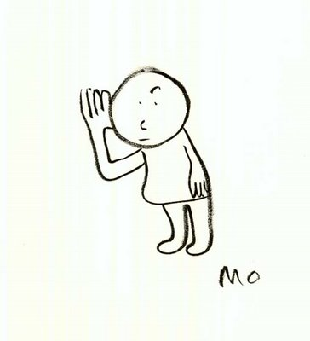

* Always look a customer in the eye-don’t stare but they need to know they have your full attention. (In some Asian cultures, continuous eye contact is rude).
* Adjust your facial expression according to the situation: be relaxed and smiling wherever possible, show concern if a customer is angry etc.
* Always ask them how you can help.
* Be clear about their requests - if you’re not sure exactly what they want –ask them to clarify it.

Always speak slowly and clearly – a customer may be hard of hearing, English may not be their first language or they may have a very different accent to you and it’s important that your message is being understood first time. You may be able to think of many other reasons.

* Be aware of accents & people’s ability to understand (this applies to both you and the customer) Always speak clearly & slowly (never mumble). If either you or they are failing to understand each other, slow down and go over what has been said again. The worst thing you can do is fail to understand exactly what they want, or fail to make yourself understood to them.
* If a customer is speaking more slowly than you, alter your speed of speech to more closely match theirs.
* Try to smile as much as you can (but make sure it’s a natural smile!)
* Spend the next few days trying to be ultra-aware of your facial expressions. Your face reveals a whole spectrum of emotions and you must be sure you’re portraying the right ones. Look at the position of your head & shoulders; a raised head shows a willingness to listen & an interest in what’s being said, whilst a lowered head can make you seem suspicious, insecure or uninterested. A tilted head shows interest (but don’t tilt it too far or you might seem like you’re flirting!)

**Transactional Analysis**

Transactional Analysis (TA) offers us a way of understanding personality, behaviour and relationships. It’s a theory of human interactions developed by Dr Eric Berne in the 1960’s. The first basic concept is of ego states - that a person can be in Parent, Adult or Child – of behaviour, thoughts, feelings and speech.



**The Parent State** – This is the way people behave, feel and think that is an unconscious mimicking of how their parents (or other parental figures) acted. For example, a person may shout at someone out of frustration because they learned from a parent in childhood the lesson that this seemed to be a way of relating that worked.

**The Adult State** – This is the way people behave, feel and think in response to what is going on at present, using all of their resources as an adult human being with many years of life experience to guide them.

**The Child State** – This is the way that people revert to behaving, feeling and thinking close to how they did in childhood. For example, a person being told off by their employer may look down and feel shame or anger, in the same way they did when being told off as a child.

Transactions are the flow of communications. A simple, reciprocal (equivalent), or complementary transaction is when both people are communicating in the same ego state. Here are some examples of interactions less straightforward:

|  |  |  |
| --- | --- | --- |
| **Adult – Adult**  1: Have you been able to write the report?  2: Yes I am about to email it to you. | **Child – Child**  1: Would you like to skip the meeting and go and watch a film with me instead?  2: Yes, I don’t want to work anymore, what shall we go and see? | **Parent – Child**  1: You should have your room tidy by now!  2: Stop hassling me, Ill do it eventually! |

**THE IMPORTANCE AND PRINCIPLES OF BODY LANGUAGE**

Your body language is crucial to making a good impression. Watch other people around you and see if you can judge their mood or attitude from the way they are carrying them self. Remember, it’s important to recognise what is happening with your own body language.

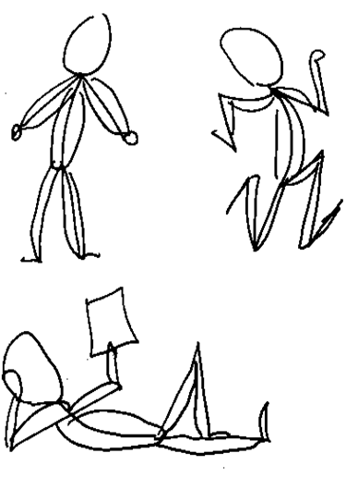

* Leaning slightly forward shows concern and interest. Leaning away of folding your arms shows boredom or disinterest. Putting your hands on your hips shows aggression.
* Don’t stand too close to a customer-you will intimidate them. Try to maintain a distance of 3-4 feet.
* Be aware of any gestures you make-all gestures send messages, both good & bad. Fiddling with objects or yawning are obvious signs of boredom. Pointing at someone shows aggression, but pointing at objects or places can reinforce what you’re saying.
* Just as it’s important for you to recognise and understand how your body language, posture, gestures and tone of voice contribute to the impression you’re making, its equally important to recognise and understand that the same is true for your customer. You need to get used to reading their gestures & behaviour so that you can determine their state of mind and react to it accordingly.
* There are lots of types of customer behaviour that you need to be aware of and understand e.g.: Raising a hand is a request for assistance.
* Looking at a watch suggests impatience, so you may need to deal more promptly with this customer.
* A customer who looks upset or confused needs immediate gentle care.
* You will find that you read most types of human behaviour instinctively and will probably naturally react in the most appropriate way, but try to spend the next few days being more aware of your behaviour and that of those around you.

**YOUR ORGANISATION’S PROCEDURES**

You will probably find that your organisation has a specific set of procedures in place for dealing with customers face-to-face. Talk to your line manager and make sure that you fully understand these procedures and how they apply to your role at work.

If your work is carried out from behind a barrier or screen, you need to adjust your face-to-face customer service accordingly. Screens create a barrier between you and your customer that can be both physical and psychological. Make allowances for this so that your customer still feels that they are receiving a high standard of care. You may need to speak more loudly and clearly.

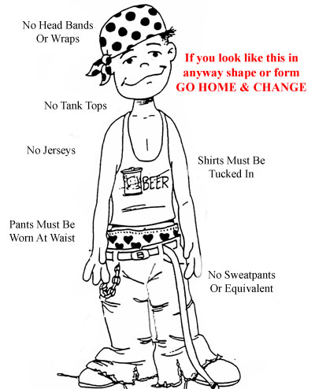

Your organisation may have specific procedures for dealing with complaints. You may for example, need a superior staff member to authorise the return of faulty goods or to approve a refund. In circumstances like this, always take the time to explain the procedure to your customer-let them know what action you’re taking and why.

**DRESS CODE:** Many organisations have a strict dress code. Make sure you follow this code of practice so that you present a positive image to your customers at all times.

Well, I’m dressed aren’t I?

**FAMILIARISE YOURSELF WITH YOUR ORGANISATIONS SERVICES**

Good customer care goes hand in hand with good understanding and knowledge of the services and products your organisation offers. Customers expect and deserve to be met and looked after by a member of staff who can explain the features and benefits of the services or products they’re enquiring about.

* Make sure that you really understand the features and benefits of your organisations services or products. If there are areas you are unsure of, take the time to find out as much as you can about them. As your line manager or supervisor to explain anything that’s not clear.
* Take the time to read and familiarise yourself with any information, product literature or service information leaflets.
* Pick a couple of products or services each week and take some time to find out as much as you can about them.
* Make sure your knowledge is up to date. Take the time to find out about specific offers or promotions available to your customers.

**Being familiar and well informed of your organisations services will make you far more confident and more able to deal professionally with any customer enquiry. Once you’ve read and understood this unit summary, complete the questions that follow.**

**UNIT 16 Assessment Activities**

**This unit is all about the skills you need to deal with your customer in person and face-to-face.**

**When you are working** with a customer face-to-face, good feelings about the way you look and

**Key words and phrases for this unit:**

• communicating

• working face-to-face

• understanding behaviour

• giving a professional image

• balancing demands

• understanding body language

• building a rapport

• keeping focused

behave can improve how your customer feels about the transaction and give them greater

satisfaction.

While verbal communication is important, your focus on your customer and the relationship that

is formed also depends on the non-verbal communication that takes place between you. You

have many opportunities to impress your customer and your behaviour in this situation can make

all the difference to customer behaviour and the satisfaction that they feel.

|  |
| --- |
| **⮛ START HERE ⮛** |

1. **Why is it important to speak slowly and clearly when face-to-face with a customer.**  *16.ku.a*

2. **Why is it important to listen attentively to your customer?** *16.ku.b*

3. **What standard procedures are in place for when you meet and greet your customers face-to-face.** *16.ku.c*

4. **List the features and benefits of your organisation’s services or products.** *16.ku.d*

5. **Having engaged with the customer, how does your organisation expect you to progress the transaction.** *16.ku.e*

5. **Give three examples of body language you might recognize in a customer and explain what each my tell you about their feelings and mood.** *16.ku.f*

|  |  |
| --- | --- |
| **Feeling or mood** | **Body language** |
|  |  |
|  |  |
|  |  |

7. **In not less than 100 words, summarise the behavioural model known as Transactional Analysis and give at least one example of how this could improve your ability to interact with customers.** *16.ku.g*

8. **Explain why the expectations and behaviour of individual customers will demand different responses to create rapport and satisfaction.** *16.ku.h*

The knowledge and understanding from unit 16 has been satisfactorily completed, all work carried out by the learner

Assessor’s Name: Signature:

The work in this unit is all my own

Learner’s Name: Signature: Signature:

Date:

Assessor Feedback:

**Below are the standards for Unit 16.**

**Working with your assessor you will need to provide evidence that you are competent in each standard.**

***UNIT 16*** *Customer Service Standards*

***When you are dealing with customers face-to-face you must consistently:***

*16.p1.a) plan a conversation with your customer that has structure and clear direction*

*16.p1.b) hold a conversation with your customer that establishes rapport*

*16.p1.c) focus on your customer and listen carefully to ensure that you collect all possible information you need from the conversation*

*16.p1.d) explain your services or products and your organisation’s service offer to your customer clearly and concisely*

*16.p1.e) adapt your communication to meet the individual needs of your customer f anticipate your customer’s requests and needs for information*

*16.p1.g) balance conflicting demands for your attention whilst maintaining rapport with your current customer*

*16.p1.h) calm down situations when one customer is adversely affecting the customer service enjoyed by other customers*

*16.p2.a) present a professional and respectful image when dealing with your customer*

*16.p2.b) show an awareness of your customer’s needs for personal space*

*16.p2.c) focus your attention on your customer so that non-verbal cues do not betray disinterest, boredom or irritation*

*16.p2.d) ensure that your customer focus is not disrupted by colleagues*

*16.p2.e) observe all customers and the total customer service situation whilst maintaining rapport with your current customer*

*16.p2.f) observe your customer to read non-verbal clues about their wishes and expectations1.p.1a) explain what your organisation does and the types of customers it has*

***People competent at dealing with customers face-to-face know and understand:***

*16.ku.a) the importance of speaking clearly and slowly when dealing with a customer face-to-face*

*16.ku.b) the importance of taking the time to listen carefully to what the customer is saying*

*16.ku.c) your organisation’s procedures that impact on the way you are able to deal with your customers face-to-face*

*16.ku.d) the features and benefits of your organisation’s services or products*

*16.ku.e) your organisation’s service offer and how it affects the way you deal with customers face-to-face*

*16.ku.f) the principles of body language that enable you to interpret customer feelings without verbal communication*

*16.ku.g) how individual transactions between people can be understood by using a behavioural model such as transactional analysis*

*16.ku.h) why the expectations and behaviour of individual customers will demand different responses to create rapport and achieve customer satisfaction*

*16.ku.i) the agreed and recognised sector cues in customer behaviour that indicate that your customer expects a particular action by you*

|  |
| --- |
|  |

**On-programme administration checklist**

|  |  |
| --- | --- |
| **Activity to be completed at the end of this unit** | **Assessor’s initials** |
| 1) Complete Action/Review Plan with learner |  |
| 2) Forward copy of assessment plan/review to Administration |  |
| 3) Update Skillwise |  |

All administration for the end of Unit 16 is complete

Signed…………………………………………. Date…………………