Module 3: Give customers a positive impression of yourself and your organisation
Y
our company relies upon your ability to give a positive impression of your organisation; remember you don’t get a second chance to make a first impression!

What does this mean? If you don’t deliver a high standard of customer services at your first meeting there is a good chance that the customer will not return. This is also relevant to your present customer base, good customer service doesn’t stop once you’ve got them hook and reeled in.

You may have rules and regulations regarding the style of clothing worn if uniforms are not provided, some employers also have set rules and regulations with regard to make-up, jewellery, piercings and standards of personnel hygiene as well as presentation i.e. uniform must be neat tidy and ironed. This may sound very regimented but is an essential part of the customer service industry.

Written complaints should have a time limit for a response: this may include a telephone call or a holding letter whilst you carry out a full investigation into the problem. Minor complaints should be dealt with a.s.a.p. This will depend on your organisation’s rules and regulations.

MAKING A POSITIVE IMPRESSION

Your customers will form a first impression of you within seconds of meeting you. YOU MUST MAKE THIS IMPRESSION THE BEST YOU CAN! When you first meet a customer the impression you make on them will be influenced by your appearance, your behaviour, your ability to communicate and may also be affected by the way in which you deal with difficult situations.

Let’s look at each of these in turn and address the ways in which you can really make a difference.

APPEARANCE
Everyone judges each other on their appearance, it’s an instinctive part of your human nature and you make a decision based on what you see, extremely quickly. As a representative of your organisation-the way you look, appear and even smell combines to create an image which is crucial to the success of the business. So:
- BE SMART: smartness never offends.
- If you have a uniform – wear it well.
- Make sure your hair is clean and neat. If it’s long – think about tying it back.
- If you wear make-up – keep it subtle-too much make-up often offends.
- Make sure you have clean hands and nails.
- Make sure you have good personal hygiene – always ensure you’re clean and use deodorant. Never over do your perfume or aftershave, and keep your teeth clean – your smile is the first thing a customer should see!

BEHAVIOUR
Your behaviour is as important as your appearance:
- Always be polite, whatever the situation-to both customers and colleagues alike.
- Become a good time-keeper, late arrival at work only antagonises your colleagues and creates a bad impression.
- Be mature and act sensibly
- Never discuss work or other colleagues in front of others. No-one likes a gossip and its unprofessional.
- Always attend to a customer’s needs first. Look after them whilst they are on your premises and give them your full attention at all times. If you can’t help them, find out who can.
- Always offer to help a customer, and try to give them the information they need, promptly and politely.
COMMUNICATION
Good communication is about listening and responding politely and effectively.
- Be polite, warm and friendly.
- Always look your customer in the eye, smile and speak clearly.(Be aware that some customers might have hearing difficulties)
- Never swear!
- If you’re dealing with customer son the phone your organisation will probably have advised you of the way in which you should answer incoming calls.
- It’s useful to know the phonetic alphabet for spelling out difficult words.

THE PHONETIC ALPHABET

A Alpha  B Bravo  C Charlie  D Delta  E Echo  F Foxtrot  G Golf | H Hotel  I India  J Juliet  K Kilo  L Lima  M Mike | N November  O Oscar  P Papa  Q Quebec  R Romeo  S Sierra  T Tango | U Uniform  V Victor  W Whisky  X X-Ray  Y Yankee  Z Zulu

GRAMMAR AND SPELLING
- If you’re dealing with customers via fax, email or by letter always respond promptly, check and double check your grammar and spelling and ensure that you include all your contact details (company name, address ,contact numbers and email etc.
- If you’re sending a fax always use a header sheet with your organisations contact details and a brief personal note from you explaining what you are sending.
- If you regularly use email, ensure that you have an “out-of office reply” in place for your days off and holidays.

DIFFICULT SITUATIONS
Your customers will not always approach you in a friendly way. Sometimes they may feel angry or are confused and unclear about something and they may display aggressive behaviour. The way in which you react to this sort of situation is crucial. Watch out for any visual signals that may suggest a customer is unhappy or confused; their voice, posture and gestures will usually show signs.
Angry Customer
Shouting – raised voice, with an abrupt tone
Arms may be being waved about
Red face

Confused Customer
Furrowed eye brows
Wandering around aimlessly
Quiet and low pitched voice

Your aim in any difficult situation where a customer is unhappy is firstly to calm them down and secondly to resolve the problem.
- Try to recognise distress signals quickly and respond by showing a genuinely caring interest in their problem. Listen carefully to their complaint and repeat the key issues back to them so that they know you’ve understood.
- Try to establish exactly what they expect to be done to resolve the problem and show reassure that you’re here to help.
- Apologise. An apology almost always calms a difficult situation. You don’t need to apologise for what they may feel your organisation has done, you are simply saying that you’re sorry that they’ve had a bad experience.
- Don’t promise to do anything beyond your ability to rectify the situation. Think carefully about what you can genuinely do, if you’re not sure explain to the customer that you need to ask one of your colleagues to help.
- Always report any complaints to your line manager.
- If necessary follow up any complaint to ensure 100% that the customer was happy with the way it was resolved.

THE RIGHTS OF YOUR CUSTOMERS
All customers have a right to be treated fairly and to expect a high level of service at all times. Make every customer your top priority; respond to any requests they have as quickly and efficiently as you can. Try to anticipate their needs and offer assistance without being asked.
Follow the simple RIGHTS rule below and your customers will feel happy and satisfied with the level of customer care you provide.

RESPECT

INFORMATION

GREETING

HELP

THANKS

SMILE…

RESPECT

Respect your customers. Treat them as you’d expect to be treated yourself. Provide an excellent level of care and your customers will respond by telling their friends and family how happy they are with the service you provide.
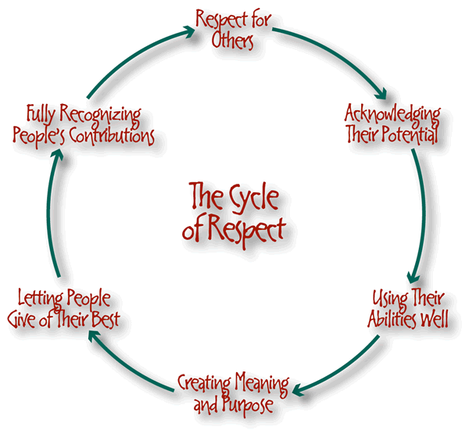
Information. Customers constantly require information from you, from simple queries to more complicated requests. It’s your job to provide this information promptly and efficiently.
Greeting your customers is an important part of your daily work. Greet all customers in a friendly welcoming way with a smile on your face. It is important to find out the names of your customers and use their name when you can. It makes a customer feel valued if they think you’ve taken enough interest to find out who they are. Make sure you also say Good-bye as a customer leaves.
Help your customers at every opportunity! Offer them assistance before they have to ask and always show that you’re ready and willing to help at any time for any reason.
Thank your customers! Make them feel appreciated whenever you can, a thank you for choosing your organisation or for using your services will make customers feel valued and therefore more inclined to return.
Smile! It’s one of your greatest customer service assets! Maintain a friendly cheerful manner at all times when you’re working. Leave your problems and personal worries at home, being happy at work creates an extremely positive impression for customers and ultimately boosts your organisations reputation as a great place to work.

Module 3: Assessment Activities

This unit explores how you communicate a positive and confident impression to the customer

Excellent customer service is provided by people who are good with people.
Key words and phrases for this unit:
• meet and greet customers
• communicate with customers
• adapt behaviour for customers
• identify customer expectations
• give information to customers
• check customer understanding
• respond appropriately to customers
• locate information for customers
• explain problems of delivery to customers
Your behaviour affects the impression that customers form of the service they are receiving.
This Unit is all about communicating with customers and giving a positive impression of yourself whenever you deal with a customer. By doing this you will also be giving a positive impression of your organisation and the customer service it provides.
All of us enjoy the experience of good customer service if we feel that the person serving us really wants to create the right impression, respond to us and give us good information. Every detail of your behaviour when dealing with a customer counts.

START HERE
1. Describe your organisation’s standards for appearance. (If available insert a photograph of you in your company uniform). 9.ku.a

PHOTO HERE

2. How do you recognize when your customer requires service and what do you do to respond appropriately? 9.ku.b; 16.ku.i

3. Tick below methods of communication that you use at work noting any rules or procedures you must adhere to. 9.ku.c

Method | Tick all that apply | Rules and procedures
a. Face-to-face
b. Phone
c. Fax
d. Email
e. Internet
f. Intranet
g. Text
h. Letter
i Other

4. Recognising difficult situations involving customers. 9.ku.d

4a. Give 2 examples of behaviour that would or could indicate that a customer is angry

4b. Give 2 examples of behaviour that would or could indicate that a customer is confused

5. What is the time limit your organisation requires of you to deal with customer queries or requests for information. 9.ku.e

The knowledge and understanding from module 3 has been satisfactorily completed

Assessor’s Name: Signature:

Learner’s Name: Signature: Signature:

Date:

Assessor Feedback:

Below are the standards for Unit 9.
Working with your assessor you will need to provide evidence that you are competent in each standard.

Module 3: Customer Service Standards

When you give customers a positive impression of yourself and your organisation you must consistently:

9.1.a Meet your organisations standards of appearance and behaviour
9.1.b Greet your customer respectfully and in a friendly manner
9.1.c Communicate with your customer in a way that makes them feel valued and respected
9.1.d Identify and confirm your customers expectations
9.1.e Treat your customer courteously and helpfully at all times
9.1.f Keep your customer informed and reassured
9.1.g Adapt your behaviour to respond effectively to different customer behaviour
9.2.a Respond promptly to a customer seeking assistance
9.2.b Select the most appropriate way of communicating with your customer
9.2.c Check with your customer that you have fully understood their expectations
9.2.d Respond promptly and positively to your customers' questions and comments
9.2.e Allow your customer time to consider your response and give further explanation when appropriate
9.3.a Quickly locate information that will help your customer
9.3.b Give your customer the information they need about the services or products offered by your organisation
9.3.c Recognise information that your customer might find complicated and check whether they fully understand
9.3.d Explain clearly to your customers any reasons why their needs or expectations cannot be met

To be competent at doing your job in a customer friendly way you must know and understand::

9.ku.a your organisation’s standards for appearance and behaviour
9.ku.b your organisation’s guidelines for how to recognise what your customer wants and respond appropriately
9.ku.c your organisation’s rules and procedures regarding the methods of communication you use
9.ku.d how to recognise when a customer is angry or confused
9.ku.e your organisation’s standards for timeliness in responding to customer questions and requests for information

