⚫ **UNIT 5: Provide customer service within the rules**

**R**

**ules and regulations are essential to any organised activity. If someone breaks the rules when you’re playing a game the whole game becomes pointless and you’ll quickly lose interest in playing. The same is true in the work place where it’s essential that everyone understands and works within the rules at all times.**

**INTERNAL RULES**

Every organisation has its own set of rules and regulations which all staff must understand and obey. These rules are often referred to as Codes of Practice and you should fully understand and be familiar with those set out in your organisation.

These could include:

* A customer care policy
* A complaints procedure
* Company induction
* A returned goods policy
* An equal opportunities policy.
* Ask your employer about the codes of practice that have been put in place for your organisation.
* Internal rules also cover the rules that relate specifically to you and your role within the organisation.

You should have been given a “Job Description” when you started work. This job description should clearly explain your role within the organisation, a list of your duties and your responsibilities. If you haven’t been given a job description ask your line manager to explain exactly what is expected of you.

**Your job description is important for two reasons:**

**1. It tells you what you should be doing and how you should be doing it.**

**2. It also tells you the limits of your responsibilities, ie what duties are outside of your responsibility and what you should do to ensure that each and every customers needs are met if you cannot meet these needs yourself.**

So you must know your limits within your job description and know how to deal with any aspect of customer service that falls outside these limits. If you’re unclear about this -talk to your line manager.

Internal rules will often be bound by external rules so lets look at these next.

**EXTERNAL RULES**

All organisations are bound by a set of external rules which exist to ensure the safety and well being of its customers and staff and ensure that the organisations activities are safe and legal.

It is very important that you understand these rules and how they affect your duties and responsibilities, so we need to look at each one in detail.

**YOUR CUSTOMERS’ RIGHTS and THE LEGISLATION THAT PROTECTS THEM**

The legislation that affects customers relates directly to the sort of activities and services carried out by your organisation. Each organisation may be bound by a different set of regulations and it’s up to you to familiarize yourself with the legislation that is relevant to your particular business. Ask your line manager and find out about any legislation that may affect your role at work.

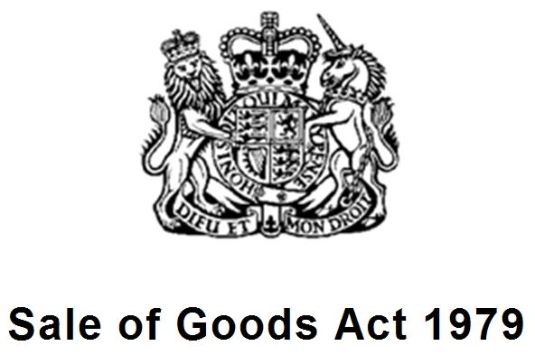

There are however two specific laws that normally apply to any area of business and you need to know what they are and what they mean to you.

**LEGISLATION**

**1. SALE OF GOODS ACT 1979**

This act relates to any goods that your business might sell and states that they must be:

* Of satisfactory quality
* Fit for their purpose
* As described by the seller (i.e. it must do exactly what it says on the tin!)

If a customer feels that any of the above have not applied to the good they’ve purchased you need to know how your organisation will deal with it. All customers have rights under this Act and your managers will be able to tell you how they go about ensuring that a complaint under these terms is handled. So find out how this complaints procedure applies to your organisation and what measures you may need to be aware of to deal with a complaint.

**2. TRADES DESCRIPTION ACT 1968**

This act applies to the way in which you describe your goods or services. Any description must be accurate. So its important that you know as much as possible about any goods or services that your organisation provides. Never guess the answer to a customer’s question; if you don’t know, find out or enlist the help of a colleague who does know.

**HEALTH AND SAFETY**

Health and safety is one of the most important areas in any organisation and ensures that there is a safe and secure environment for both customers and staff at all times. There are a set of legal regulations in place which are concerned with health and Safety and these include :

**1. HEALTH AND SAFETY AT WORK ACT 1974**

This act is all about ensuring your safety and the safety of others. Every employee is responsible for reporting dangers and making sure they’re put right. It ensures that you work within a set of guidelines and do not break any laws concerning health and Safety.

Your organisation will have a specific Health and Safety policy which will probably cover the following:

* Tackling hazards in the workplace and how you should deal with any that occur.
* Using equipment designed for the job and ensuring that its safe and well maintained.
* Wearing any allocated uniform which is normally there to protect you.
* Ensuring there are no fire risks (this will relate to electrical equipment, general housekeeping and smoking.)
* Ensuring that any lifting in the line of work is done correctly and that staff are aware of safe lifting techniques and good posture etc
* How to report an accident or hazard in the workplace.

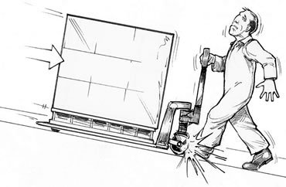

Each organisation will have its own specific health and safety policy and you must familiarise yourself with yours. Your business will also display a poster for staff to see clearly which explains Health and safety law. Have a look at it!

For more information on Health and safety visit the Health and Safety Executive information website at : [www.hse.gov/worker/index.htm](http://www.hse.gov/worker/index.htm)

**2. COSHH (Control of Substances Hazardous To Health Regulations 2002)**

This set of regulations ensures that all substances used in the work place are handled safely and responsibly. Your employer has a duty to maintain your safety by providing you with information about the controls necessary to reduce any risk of harm. Employers must also carry out a risk assessment which will establish protective measures, monitoring and health surveillance where necessary.

**3. MANUAL HANDLING REGULATIONS 1997**

These regulations are designed to reduce the risk of injury at work. They state that if a task may result in injury that task should be avoided or re-designed to avoid risk. If this is not possible the employer should assess the risk and reduce its likelihood of occurring.

**4. THE ELECTRICITY AT WORK ACT 1989**

These regulations protect staff and customers from electrical injury by ensuring that all electrical equipment is well maintained and regularly tested by a qualified PAT (Portable Appliance tested) electrician. You have probably noticed a PAT label on the equipment in your work place-each label has an expiry date and any organisation with equipment that has an out of date PAT label is in breach of these regulations.

**5. RIDDOR 1995**

This is the Reporting of Injuries, Diseases and Dangerous Occurrences Regulation and places a legal duty on **a)**

**employers; b) self-employed people and c) people in control of premises** to report work-related deaths, major injuries or over-three-day injuries, work related diseases, and dangerous occurrences (near miss accidents).

**OTHER LEGAL ISSUES THAT APPLY TO YOUR ORGANISATION**

**DATA PROTECTION ACT 1998**

This act protects any individuals privacy. If your organisation holds any sort of record of information on individuals you have a duty to follow a set of rules to make sure this information is protected from unauthorised use. This act also means that any individual has the right to know exactly what information is held on them by the organisation. You should know your organisation’s policy so that you are able to advise customers about how they can access it.

**EQUAL OPPORTUNITIES**

Your organisation will have its own equal opportunities policy and you should familiarise yourself with them. They should be based on legislation which prevents discrimination on certain grounds. Here are the main Acts:

* Ethnicity, race, colour or nationality. **RACE RELATIONS ACT 1976**.
* Earnings of males and females undertaking the same work. **EQUAL PAY ACT 1970**
* Disability. **DISABILITY DISCRIMINATION ACT 1995. (**From 2004, all service providers have had a duty to ensure their premises and the services they offer are accessible to all.**)**
* Sex or marital status. **SEX DISCRIMINATION ACT 1975**
* Sexual orientation. **EMPLOYMENT EQUALITY REGULATIONS 2003**
* Philosophical or religious beliefs **EMPLOYMENT EQUALITY (RELIGION OR BELIEF) REGULATIONS 2003**

**SALE OF GOODS ACT 1979** (now known as: Supply of Goods to Consumers Regulations 2002)

The Sale of Goods Act protects the customer and says that all goods you sell must be:

* *‘of satisfactory quality*’ which means ‘*standards that a reasonable person would regard as acceptabl*e’, bearing in mind the way they are described, what they cost and any other relevant circumstances
* ‘*fit for their purpose*’, which includes and particular purpose mentioned by the purchaser to the seller
* ‘*as described*’ on the package, display sign or by the seller.

**SECURITY AND CONFIDENTIALITY**

You should always ensure that you fully respect any individual’s confidentiality and security. You have a duty to protect their possessions whilst on your premises at all times and to the best of your ability.

**UNIT 5 Assessment Activities**

**This unit is all about how your organisation manages its relations with customers through its employees.**

**There are rules** in organisations that limit what you can and cannot do for customers.

**Key words and phrases for this unit:**

• follow organisational procedures

• recognise limitations

• refer on

• follow external regulations

• follow external legislation

• work safely

• respect confidentiality

• awareness of security

Some rules are set by your organisation and some are defined by law and apply to everybody’s jobs. Other rules are set by regulations that apply to particular industries. You need to know your organisation’s rules and procedures and how these limit what you can do for customers. You also need to be aware of the wider laws and regulations which are set outside of your organisation and how they apply to you and your job.

|  |
| --- |
| **⮛ START HERE ⮛** |

1. **Give 3 examples of organizational procedures and regulations that apply specifically to you and your job role**. *5.ku.a; 5,ku.f*

2. **Give 2 examples of procedures or processes where you have to involve a supervisor/manager.** *5.ku.b*

3. **Identify 3 health and safety risks or hazards that could face customers and describe what you’d do to ensure the safety of customers and/or their property.**  *5.ku.c;*  *5.ku,d; 21.ku.d*

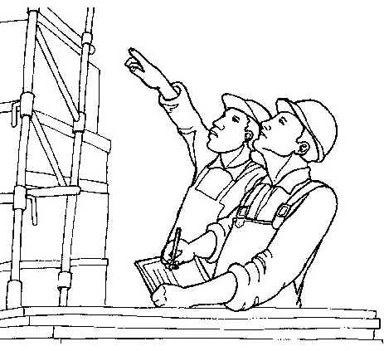

5. **In your job role give two examples of health and safety procedures that instruct**

**you in what you can and cannot do.** *5.ku.g; 21.ku.d*

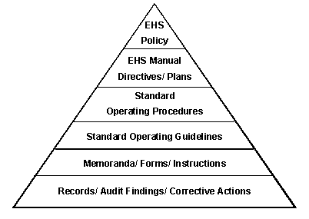

4. **Explain the importance of customer confidentiality of information belonging to both the organisation and the customer and explain some of the limits of what you are allowed to do.**  *5.ku.e*

|  |  |
| --- | --- |
| **6. Explain how Equal Opportunities legislation affects what you can and can’t do in your job** *5.ku.g.i* | |
| What I can do | What I can’t do |
| **7. Explain how Disability Discrimination legislation affects what you can and can’t do in your job** *5.ku.g.ii* | |
| What I can do | What I can’t do |

**Your organisation’s own policies are the best place to look for information if you’re unsure about any of these questions but for other, general, information try these internet sites:**

Equality and Diversity: http://www.aboutequalopportunities.co.uk/

Disability Awareness: http://www.direct.gov.uk/en/DisabledPeople/Employmentsupport/YourEmploymentRights/DG_4001071

Data Protection: http://www.ico.gov.uk/for_organisations/data_protection_guide.aspx

Health and Safety Legislation: http://www.hse.gov.uk/legislation/trace.htm

Employment Rights and Responsibilities: http://www.adviceguide.org.uk/index/your_money/employment/basic_rights_at_work.htm

|  |  |
| --- | --- |
| **8. Explain how Data Protection legislation affects what you can and can’t do in your job** *5.ku.g.iii* | |
| What I can do | What I can’t do |
| **9. Explain how Health and Safety legislation affects what you can and can’t do in your job** *5.ku.g.iv* | |
| What I can do | What I can’t do |

Consumer Protection: <http://www.consumerrightsexpert.co.uk/>

|  |  |
| --- | --- |
| **10. Explain how employment responsibility and rights legislation affects what you can and can’t do in your job** *5.ku.g.v* | |
| What I can do | What I can’t do |
| **11. Explain how Consumer Protection legislation affects what you can and can’t do in your job** *5.ku.g.vi* | |
| What I can do | What I can’t do |

12. **Describe 3 of your employer’s security arrangements that apply to you. (For example, computer security, access to buildings, management of cash on the premises etc.)** *5.ku.h*

The knowledge and understanding from unit 5 has been satisfactorily completed

Assessor’s Name: Signature:

Learner’s Name: Signature: Signature:

Date:

Assessor Feedback:

**Below are the standards for Unit 5.**

**Working with your assessor you will need to provide evidence that you are competent in each standard**

***UNIT 5*** *Customer Service Standards*

***When you provide customer service within the rules you must consistently:***

*5.p1a) follow organisational procedures and instructions in a willing and helpful way*

*5.p1b) recognise the limits of what you are allowed to do*

*5.p1c) refer to somebody in authority when you need to*

*5.p1d) work in a way that protects the security of customers and their property*

*5.p2a) work in a way that is safe for your customers and your colleagues*

*5.p2b) respect confidentiality relating to customers and the organisation*

*5.p3c) work in a way that shows you are aware of the areas of your job that are covered by law*

*5.p4c) and the things you must not do*

*5.p5d) work in a way that shows you are aware of the main regulations that apply to your job and the things you must not do*

***People competent at providing customer services within the rules know and understand:***

*5.ku.a) organisational procedures that relate to your job*

*5.ku.b) limits of what you are allowed to do*

*5.ku.c) what might endanger customers or their property*

*5.ku.d) what health and safety risks and hazards might be faced by your customers*

*5.ku.e)why it is important to respect customer and organisation confidentiality*

*5.ku.f) the main regulations that apply to your job*

*5.ku.g) the main things you must do and not do in your job under laws covering:*

*i equal opportunities*

*ii disability discrimination*

*iii data protection*

*iv health and safety*

*v employment responsibility and rights*

*vi consumer protection*

*5.ku.h) the security arrangements of your organisation and how they apply to your job*

|  |
| --- |
|  |

**On-programme administration checklist**

|  |  |
| --- | --- |
| **Activity to be completed at the end of this unit** | **Assessor’s initials** |
| 1) Complete Action/Review Plan with learner |  |
| 2) Forward copy of assessment plan/review to Administration |  |
| 3) Update Skillwise |  |

All administration for the end of Unit 5 is complete

Signed…………………………………………. Date…………………