L2 NVQ in Cleaning & Support Services
Washrooms & General Hygiene

The aim of this workbook is to provide information on Cleaning Washrooms and General Hygiene.
Objectives:
At the end of the session you will be able to:
- Understand in more detail by reading information and completing tasks on the following:-
- Choosing the right equipment
- Safety Data Sheets
- Labels on cleaning products
- Liquid Measures
- Using ratios on product labels

Candidate Name:
.........................................................
Signature:
.........................................................
Date Completed:
.........................................................
Assessor Name:
.........................................................
Signature:
.........................................................
Date Assessed:
.........................................................

Skills checklist
Using cleaning products is a major part of your job. Mixing up the correct amount of product in the right way can reduce waste and ensure the product is effective. You need good numeracy skills to measure out quantities of cleaning product accurately and to dilute accurately. The information you need to use to do this is often found on a product label or in a chart. The skills listed in the table below will help you prepare cleaning products efficiently. Tick the skills you feel confident about now. Complete the activities in this module to help you improve on the skills you have not ticked. Return to the list again later to check any areas where you may need more practice.
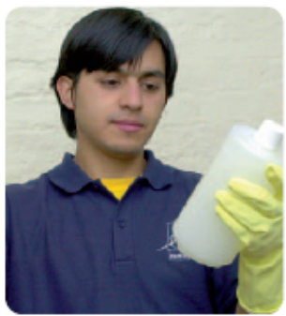

Skills for cleaning | Now | Later
Choose the correct equipment for washrooms
Find information on a label and use it to follow instructions
Measure liquids accurately in millilitres
Measure out cleaning products using a pump action dispenser
Understand and use ratios to dilute cleaning products
Use a dilution chart
Convert between millilitres and litres

Choosing the correct equipment
In order to carry out a cleaning job properly and safely, you need to choose the correct equipment. For each job you must consider:
- What are the risks?
- What can I do about them?

Risk 1: Cross-contamination
Bacteria are passed from place to place through unhygienic cleaning methods, for example by using the same cloth for the kitchen work surface as for the toilet.

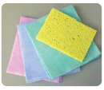
What to do about it
- Use colour-coded cleaning equipment for cleaning different areas.
- Work from the cleanest area towards the dirtiest.

Remember!
Find out about the colour-coded equipment in your place of work.

Sanitary appliances (such as toilets) and washroom floor
Consumables and washbasins

Please state the colour coding that you use in the washroom
Consumables/General: .........................................
Sinks: ...........................................
Toilets: ...........................................
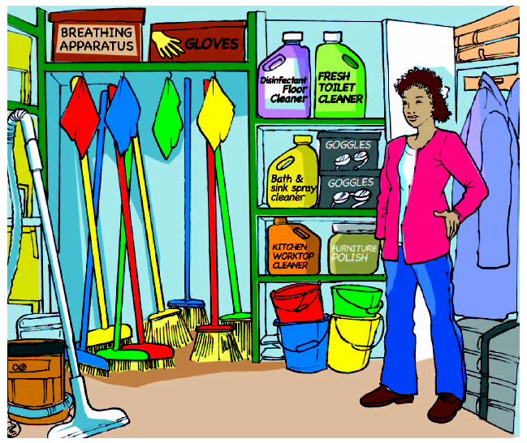
Choosing the correct equipment
You have been asked to mop the washroom floor and clean the toilets and sinks.

Circle the cleaning equipment in the picture above that you will need from the storeroom.

Choosing the correct equipment
When cleaning washrooms, it’s important to clean in the correct sequence to avoid cross contamination or risk of infection.
Number the items in the order in which you would clean them.
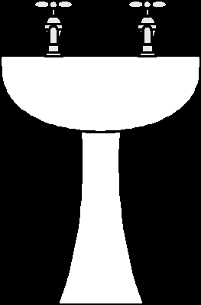

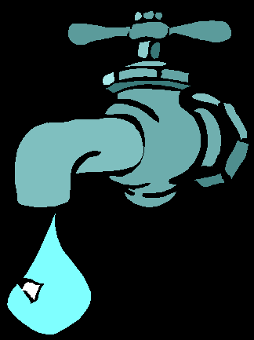


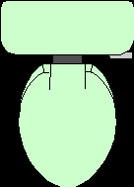

Why would it be important to ensure that waste outlets and overflows are left clean? ....................................................................................................................................................................................................................................................................................................................................................................................................................................................................................................

Why is it important to make sure surfaces are dry on completion of cleaning?
....................................................................................................................................................................................................................................................................................................................................................................................................................................................................................................

Write a list of the consumables you replace.
...................................................................................................................................................................................................................................................................................................
Why is it important to follow manufactures instructions when replacing consumables? ....................................................................................................................................................................................................................................................................................................................................................................................................
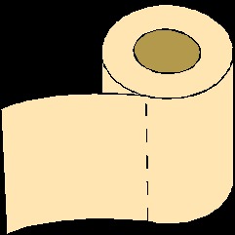

Choosing the correct equipment
- Please name a chemical that you use in the washroom

..................................................................................................................................................

- Look at the Safety data sheet extracts in your health and safety folder. Select the personal protective equipment to wear when using this product. Tick your choices below.

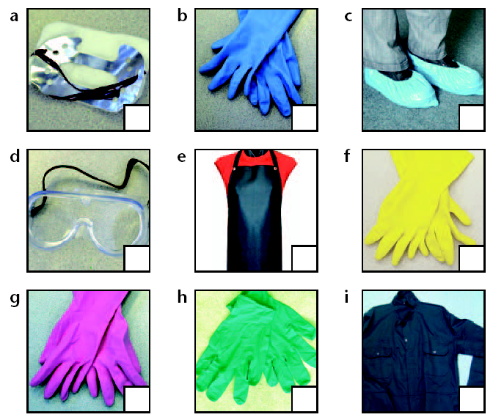
Tips
- Look for the section that gives details about personal protection.

Remember!
Choose the colour-coded PPE to suit the product.

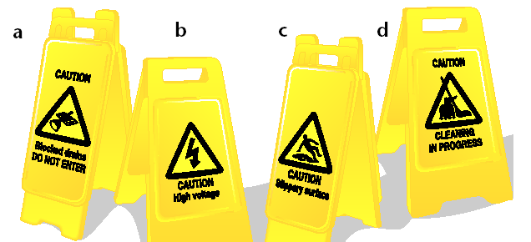
- Which warning signs should you take with you for the cleaning jobs mentioned on the previous page. Tick your choices.

Labels

The only way to be sure that a product will do what it promises is by following the instructions on the label. For example, you may need to check for dilution rates or storage requirements.
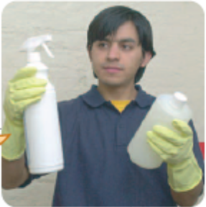
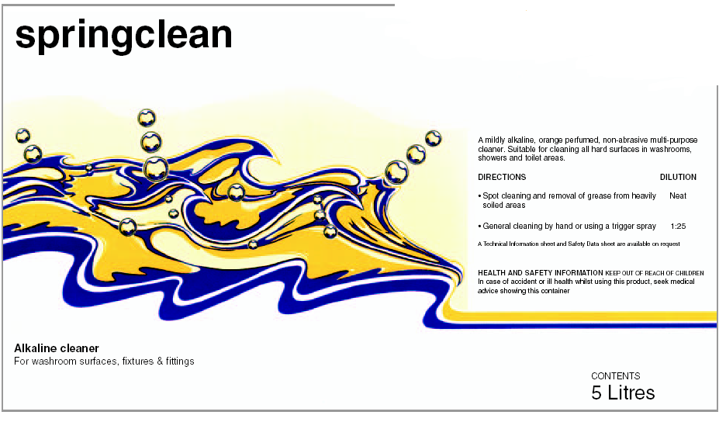
What’s the dilution rate for using this in a trigger spray?
You can find the information you need by looking out for:
- Key words
you don’t need to read the whole label. Just search for the word you want, as if you are looking for a familiar face in a crowd.
- subheadings
These might be written in: CAPITAL LETTERS bold italics or Underlined
- How quickly can you spot the word DILUTION above?

- What are the subheadings on the label above?
...................................................
......................................................................................................

- Does the list use numbers or bullet points?
..................................................

- Where can you find out more information about this product?
......................................................................................................
- What are the warnings on this label?
...................................................
...................................................

- Information set out in different ways
it could be in a list with numbers or bullet points, or in a table.

- details about where you can find out more about the product
This might be made obvious by a change of print.
- WARNINGS
These are often put in capital letters.

Labels
When dealing with a new label, you will probably find words that you’re not familiar with. There are several strategies you can use to work out their meanings.
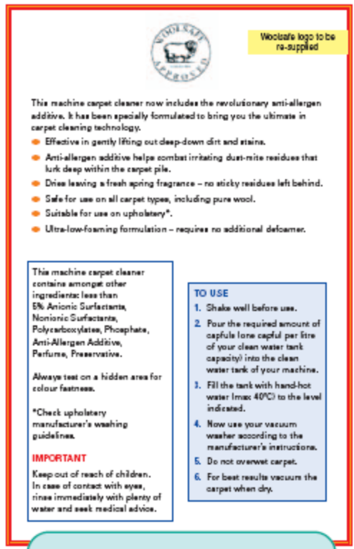

What’s an allergen?
It’s something that causes an allergic reaction.
Right, so an anti-allergen is something that stops an allergic reaction?
That’s it.
Look it up in a dictionary.
A dictionary is a list in alphabetical order of all the different meanings of words.

For example, ‘to bring you the best in carpet cleaning’
‘Anti’ can mean against or preventing. You may find parts of some words in lots of other words, e.g.
Anti-aircraft
Antibiotic
Antibacterial
Anticlockwise
Antidepressant
Once you know that ‘anti’ means against or preventing, you can guess that an anti-allergen is something that is against or prevents allergens.
Ask somebody else to explain it.
Use the other words around it, or other words like it, to work out the meaning.
A glossary is an alphabetical list of specialist words and their meanings, e.g.
Phosphate a chemical that contains phosphorus phosphorus a poisonous, yellowish-white chemical that shines in the dark and burns when in the air.
Do a combination of any or all of these!
If you find the meaning of a word from a dictionary, glossary or by asking someone, try putting it into your own words or explain it to someone to check that you’ve got the right meaning.
Once you understand the meaning of a specialist word, try to use it.
- What does additive mean?
...........................................................................................................................................................................
.........................................................

- What is another word for combat?
....................................................................................................................................................................................................................................

- On the label above, does fastness mean:

a the speed of cleaning or
b not fading or being washed away?
Ultimate the best of its kind
Look it up in a glossary.
Look it up on a specialist website on the Internet.

Labels
The instructions on labels tell you exactly how to use the product and should be followed exactly.
DIRECTIONS
TO USE:
INSTRUCTIONS FOR USE
Look out for these words:
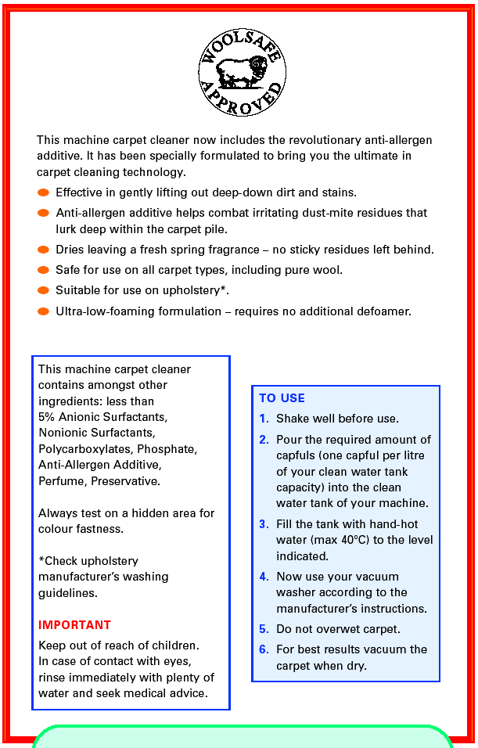
When you see them, read all the information that follows carefully, before using the product. There may be something important at the end.
- If the list of instructions is numbered, it probably means you have to do things in a particular order.
- Bullet points mean the order is not as important.
Abbreviations
Can be used for:
- measures, for example:
ml = millilitre
l = litre
- or for words, for example:
COSHH = Control of Substances Hazardous to Health

Look out for the
words that tell you
exactly what to do.

Look out for negative information:
NO, do not, NEVER, don’t
Symbols
These are a useful as a quick reference.
°C = degrees Celsius

If something puzzles you – ASK.

- On the Machine carpet cleaner label, find all the words in the ‘to Use’ box that tell you exactly what to do.

............................................................................................................................................................................................................................................................................................
- Does the symbol mean:
  - the product is safe to use on wool carpets or
  - The product is safe to use on sheep?

- How many instructions are there in the ‘to Use’ list?
.............................................................................................................................................
- What must you not do?
..........................................................................................................................................................................................................................................................................................................................................................................................................................................

- How many capfuls should be put in a 5 litre tank ...............................................................

Labels
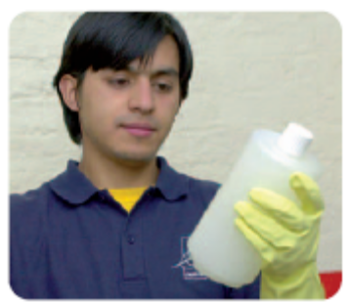
You are working in a different area for the first time. You have never used a product before. You need to read the label to find out how to use it. Obtain a bottle of the chemical you use in washrooms and answer the following

- What is the product recommended for?
....................................................................................................
....................................................................................................
....................................................................................................
....................................................................................................
- How much contact time should there be for each application?
....................................................................................................
....................................................................................................
....................................................................................................
- How should the product be used in washroom areas?
..............................................................................................
Tip
‘-cide’ means killing. A germicide kills germs.
..............................................................................................
..............................................................................................
..............................................................................................

- Find out the meanings of the following words. The first has been done for you.
  - virucidal virus-killing________________________________________
  - bactericidal __________________________________________________
  - fungicidal __________________________________________________

What do these abbreviations stand for?
- MRSA
......................................................................................................
Tip
It is important to know what these things are and how they can affect you and your work.

- HIV
......................................................................................................

- AOAC
......................................................................................................

Read the instructions below. Underline the words that tell you exactly what to do.
- Rinse with fresh water and wipe surfaces dry. Remove all excess moisture.
- Apply the diluted product with a cloth or sponge and allow contact time.

Liquid measures
Some cleaning products have to be diluted before use. This means adding water to them. Diluting generally involves measuring a small amount of cleaning product and adding it to a larger amount of water. Check your measuring skills before thinking about diluting.
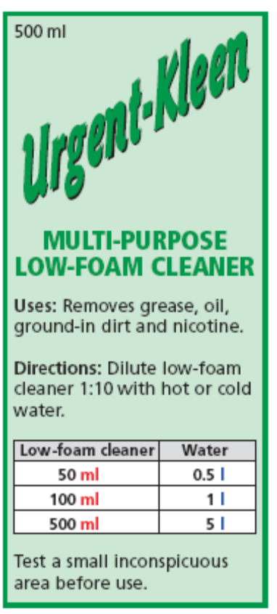

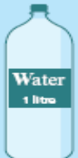
How much liquid is in 1 millilitre? 1 ml is a very small amount.

1 medicine spoon = 5 ml
How much liquid is in 1 litre?
Water and fruit juices are sold in litre bottles or cartons.
1 large bottle
of water = 1 l
Litres are standard metric units for measuring larger amounts of liquid. Litres are often shortened to l or L.
Millilitres are standard metric units for measuring small amounts of liquid. You sometimes see millilitres shortened to ml.
Remember!
- Millilitres are 1000 times smaller than litres.
- 1000 millilitres = 1 litre
- 500 millilitres = 0.5 litres
- To convert from litres to millilitres, multiply by 1000.
Try this
Put these millilitre measures in order of size, starting with the smallest:
200 ml 10 ml 100 ml
500 ml 250 ml 5 ml
1 2 3 4
5 6
Try this
Put these litre measures in order of size, starting with the smallest:
15 L 1.5 L 10 L
0.5 L 2 L 1 L
1 2 3 4
5 6
Liquid measures
Put the cleaning products below in order of size. Write the contents volume of each product, in their correct order, in the table.
Remember!
1000 millilitres = 1 litre

Smallest |  |  |  | Largest
_200 ml___ | __________ | __________ | __________ | __________

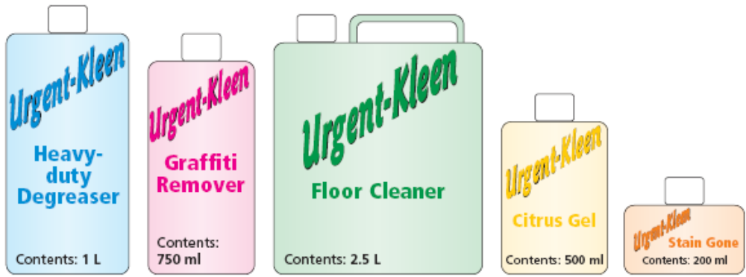

Which cleaning products does your employer buy in millilitres?
Which cleaning products does your employer buy in litres? Look in your stock room and make a list of each.
Bought in litres ____________________
________________________________
Product____________________size__
________________________________________________________________________________________________________________________________________________________________________________________________________________________________________________________________________________________________________________________________________________________________________________________________________________________________________________________________
Bought in millilitres _________________
________________________________
Product____________________size__
________________________________________________________________________________________________________________________________________________________________________________________________________________________________________________________________________________________________________________________________________________________________________________________________________________________________________________________________
Measuring water with a jug
Cleaning products need to be measured accurately before they can be diluted. A measuring jug is a useful tool for this job.
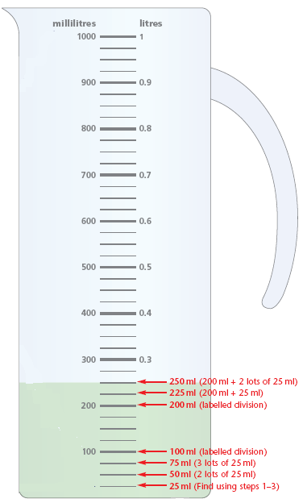

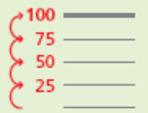
Step 2
Look at the marked divisions to see how the scale works.
Example:
Every 100 millilitre marked division is labelled, but the divisions in between are not labelled.
Step 1
Look for the scale that shows millilitres.
Tip
Instructions for measuring cleaning products are usually given in millilitres.
Cleaning products are poisonous.
NEVER measure cleaning products with a jug that will be used for food.
Now that you know the value of 1 marked division, you can work out every part of the scale.
Step 3
Calculate the value of each unlabelled division.
Example:
Each 100 ml has 4 divisions, so 1 division = 100 ml ÷ 4 = 25 ml
Check by
counting
up the scale.
Measuring water with a jug
Tip
Make sure you use the right scale on the jug.
How much cleaning fluid is in each measuring jug?

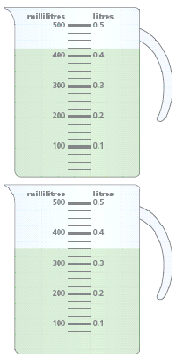
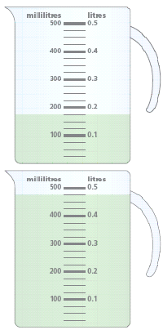
1_____ ml

- 2_____ ml

- _____ ml

- 4_____ ml

Mark the correct measures on the jugs.

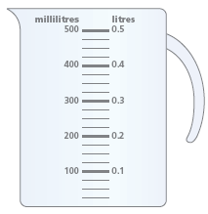
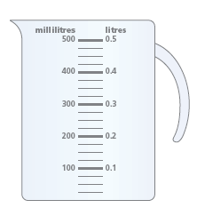

125 ml
275 ml
Using a pump action dispenser
Pump action dispensers are useful for accurate measuring. Each press of the pump dispenses a fixed amount of cleaning product.
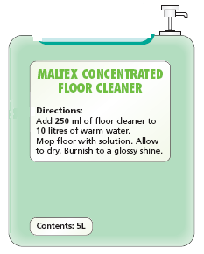
A pump action dispenser helps you to measure the correct amount of cleaning fluid. You must prime the dispenser before you use and then press it down completely to make sure you get 25 ml.
1 press = 25 ml
The product label tells you how much water and how much cleaning product you need. Look under headings such as instructions or directions.

Remember!
ml is short for millilitres
l or L is short for litres

How do I use a 25 ml pump action dispenser to measure 250 ml of floor cleaner?
Work out how many times you need to press the dispenser to measure 250 ml:
Volume volume of number of
required ÷ pump = presses
250 ml ÷ 25 ml = 10
so, 10 presses = 250 ml
Count in 25s with each press of the dispenser until you have measured 250 ml, like this:
25 … 50 … 75 … 100 … 125 … 150
… 175 … 200 … 225 … 250

or
Use the method that is best for you.

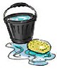
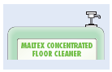
Remember!
Step 1: Measure the water
Into the container you are
going to use.
Step 2: Use the pump action
Dispenser to measure the
Cleaning product into the
water.
Dilute cleaning products precisely.
Too strong a solution may be harmful.
Too weak a solution may not clean properly.
Using a pump action dispenser

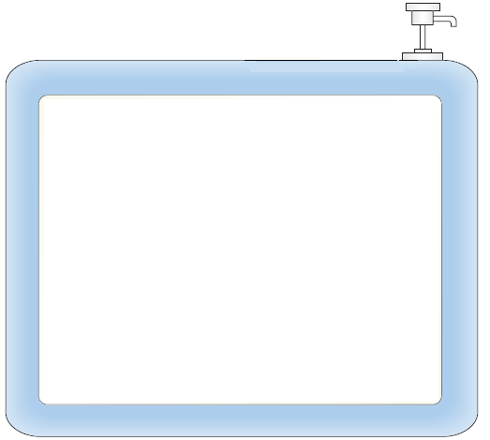
Use the information on the label to answer the questions below.
1 press = 25 ml

SORBIT MULTI-PURPOSE CONCENTRATED SURFACE CLEANER
Directions:
Task | Product | Water
Lightly soiled surfaces | 125ml | 10 litres
Heavily soiled surfaces | 225ml | 10 litres
Stained surfaces | 375ml | 10 litres
Greasy surfaces | 500ml | 10 litres
Remove excess waste. Wipe surface with diluted solution. No need to rinse.

- How many times must you press the 25 ml dispenser to
measure 125 ml of cleaning product? ________ times

- If you press the 25 ml dispenser 15 times, will the solution
be suitable for cleaning greasy surfaces? ________

- How much cleaning fluid will you have measured if you
press the 25 ml dispenser 20 times? ________ ml

- How many times must you press the 25 ml dispenser to
measure the correct amount of product for cleaning heavily
soiled surfaces? ________times
Using ratios on product labels
The labels on cleaning products often use ratios to tell you how to dilute them.
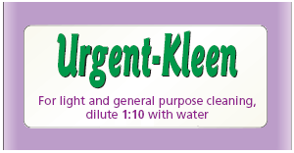
On this label, the ratio is 1:10.
You say it like this: one to ten.
A ratio of 1:10 tells you to use 1 part
of cleaning fluid to 10 parts of water.
Ratios tell you the relationship
between amounts. In a 1:10 ratio,
There is 10 times more water 1:10 means 1 part cleaning product and 10 parts water
Remember!
Always add the cleaning product to the water.
Than cleaning product.

How do I measure the parts of the ratio?
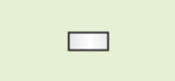
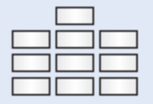
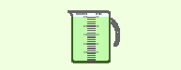
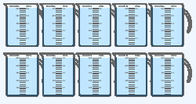
Method 1
Using a convenient sized container, count out the correct number of parts.
Example: The following mixtures are both in the ratio of 1:10.
+

+

+
Method 2
Use millilitres or litres to measure the cleaning product and water.
Example: The following mixtures are both in the ratio of 1:10.

+

+

+
Tip
You must use the same size container for the cleaning product and the water. You must fill it to the same level each time.
Tip
- If you start with the water, divide by 10 to work out how much cleaning product you need.
- If you measure the cleaning product first, multiply by 10 to work out how much water you need.

1 full jug of cleaning product

10 full jugs of water

1 capful of cleaning product
10 litres
of water
1 litre
of cleaning product
250 ml
of water
25 ml
of cleaning product

10 capfuls of water
Using ratios on product labels
Write the following amounts as ratios.
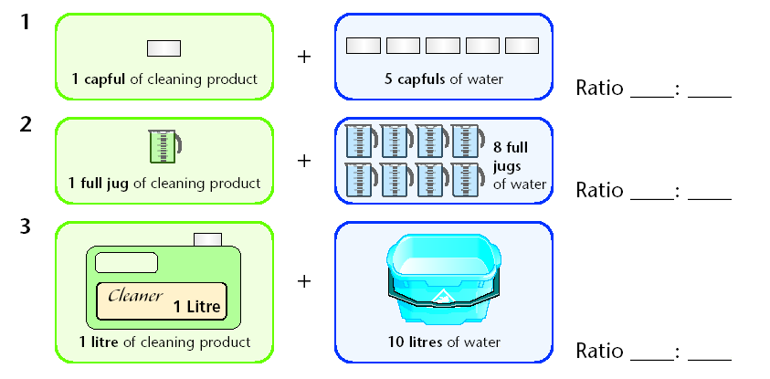

Complete the table below to show how much water is needed to make a solution of cleaning product to water in the ratio 1:5.
Ratio | Cleaning product | Water
1:5 | 50 ml | 250 ml
1:5 | 60 ml | _____ ml
1:5 | 1 litre | _____ litre
1:5 | 5 litre | _____ litre

Remember!
In a ratio of 1:5, multiply the amount of cleaning product by 5 to work out how much water you need.
Example: 50 ml × 5 = 250 ml

Complete the table below to show how much cleaning product is needed to make a solution of cleaning product to water in the ratio 1:5.
Ratio | Cleaning product | Water
1:5 | 100 ml | 500 ml
1:5 | _____ ml | 750 ml
1:5 | _____ litre | 10 litre
1:5 | _____ litre | 20 litre

Remember!
In a ratio of 1:5, divide the amount of water by 5 to work out how much cleaning product you need.
Example: 500 ml ÷ 5 = 100 ml

Using a dilution chart
Some cleaning products have a dilution chart to tell you how to dilute them.
I’ll use the 25 ml pump dispenser to measure the cleaning product.

The dilution chart tells me to press the dispenser 8 times.
I need 10 litres of water for the cleaning job I’m doing.
MIXING THE REQUIRED SOLUTION
Use the following chart to mix the appropriate cleaning solution for your cleaning task
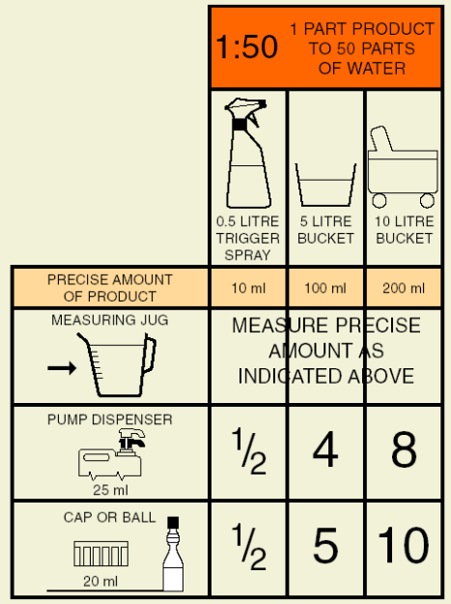
Information is organised in columns and in rows
The title tells you what information is contained on the chart.
Example: This chart is about mixing a cleaning solution in the ratio 1:50.
Column headings use symbols and words to show the different containers and amounts of water you may use for your solution.
For example, you could use:
- a trigger spray with 0.5 litres of water
- a bucket with 5 litres of water
- a bucket with 10 litres of water.
Row headings use symbols and words to show different methods you may use for measuring the required amount of cleaning product to add to the water. For example, you could use:
- a measuring jug * a 25ml pump dispenser * a 20 ml cap or ball

How do I use the dilution chart?
Step 1: Choose the amount of water you will use for your solution from the amounts shown in the column headings.
Step 2: Choose the method you will use for measuring the cleaning product from the methods shown in the row headings.
Step 3: To find how much cleaning product to measure, trace
down the column
and across the row

Read the box where the row and column meet.

Using a dilution chart
Use the dilution chart to answer these questions.
Remember!
- Trace down the column
- Trace across the row
- Read the box where the row and column meet.
- Using a finger or a ruler can help.

Decide whether the following statements are true or false.

If I measure 0.5 litres of water into a trigger spray, I need to add ½ of a 20 ml cap of cleaning product.
- True/False

If I measure 5 litres of water into a bucket, I need 5 presses of the 25 ml pump dispenser to measure the correct amount of cleaning product.
- True/False
If I measure 10 litres of water into a bucket, I need to measure 200 ml of product with a measuring jug.
- True/False

If I measure 5 litres of water into a bucket, I need to add 10 x 20 ml capfuls of cleaning product.
- True/False

How much cleaning product will you add to each amount of water?
I’ll add _____ ml of product to a trigger spray containing 0.5 litres of water.

I’ll add _____ x 20 ml capfuls of product to a bucket containing 10 litres of water.

I’ll add _____ ml of product to a bucket containing 5 litres of water.

Converting millilitres and litres
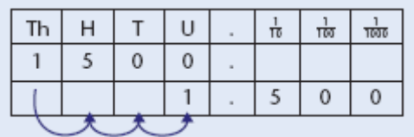
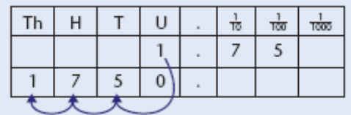
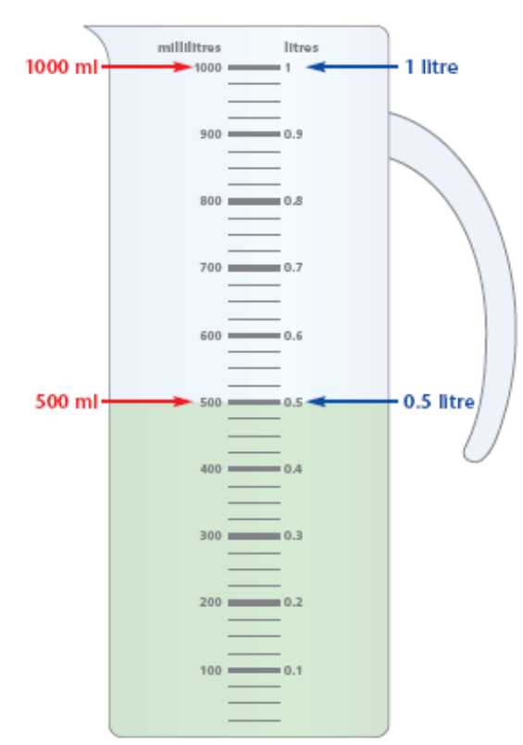
Diluting cleaning products sometimes involves converting between millilitres (ml) and litres (l).
Here are some useful conversion facts:
- 1000 millilitres = 1 litre
- 500 millilitres = 0.5 litre
How do I convert millilitres to litres? To change millilitres to litres, divide by 1000.
Example:
- 1500 millilitres = 1.5 litres
(1500 ÷ 1000 = 1.5)
- 2000 millilitres = 2 litres
(2000 ÷ 1000 = 2)
How do I convert litres to millilitres? To change litres to millilitres, multiply by 1000.
Example:
- 1.75 litres = 1750 millilitres
(1.75 × 1000 = 1750)
- 0.9 litres = 900 millilitres
(0.9 × 1000 = 900)
Tip
When you divide by 1000, all the digits move 3 places to the right.
Tip
When you multiply by 1000, all the digits move 3 places to the left.
Converting millilitres and litres
Complete the table below by converting millilitres to litres.
millilitres | calculation | litres
1250 ml | 1250 ÷ 1000 | 1.25 litres
2500 ml |  | _______ litres
4000 ml |  | _______ litres
5500 ml |  | _______ litres
10 000 ml |  | _______ litres
12 500 ml |  | _______ litres

Remember!
Divide by 1000 to change millilitres to litres.

Complete the table below by converting litres to millilitres.
litres | calculation | millilitres
0.3 litres | 0.3 × 1000 | 300 ml
0.25 litres |  | _______ ml
0.75 litres |  | _______ ml
0.15 litres |  | _______ ml
0.05 litres |  | _______ ml
0.005 litres |  | _______ ml

Remember!
Divide by 1000 to change millilitres to litres.

Dealing with Routine waste
There are several legal requirements that you and your company have to abide by here are some of them listed below:
The food safety act 1990
Controlled waste regulations 1992
Clean air act 1993
Enviromental protection act 1990
The control of pollution act 1974

Environmental health officers may call to inspect your work premises to ensure all the regulations rules are followed. The Environmental health officers are also available to help and advise you but remember they can take action if your premises are not satisfactory. They have the authority to close the premises which could result in prosecution.
During your work you may come across several different types of waste. Some of these can be hazardous to your health. This is why it is important to protect yourself and others and the environment by the way we dispose of our waste.

Dealing with Routine waste

Bin areas need to be kept clean and tidy and regularly
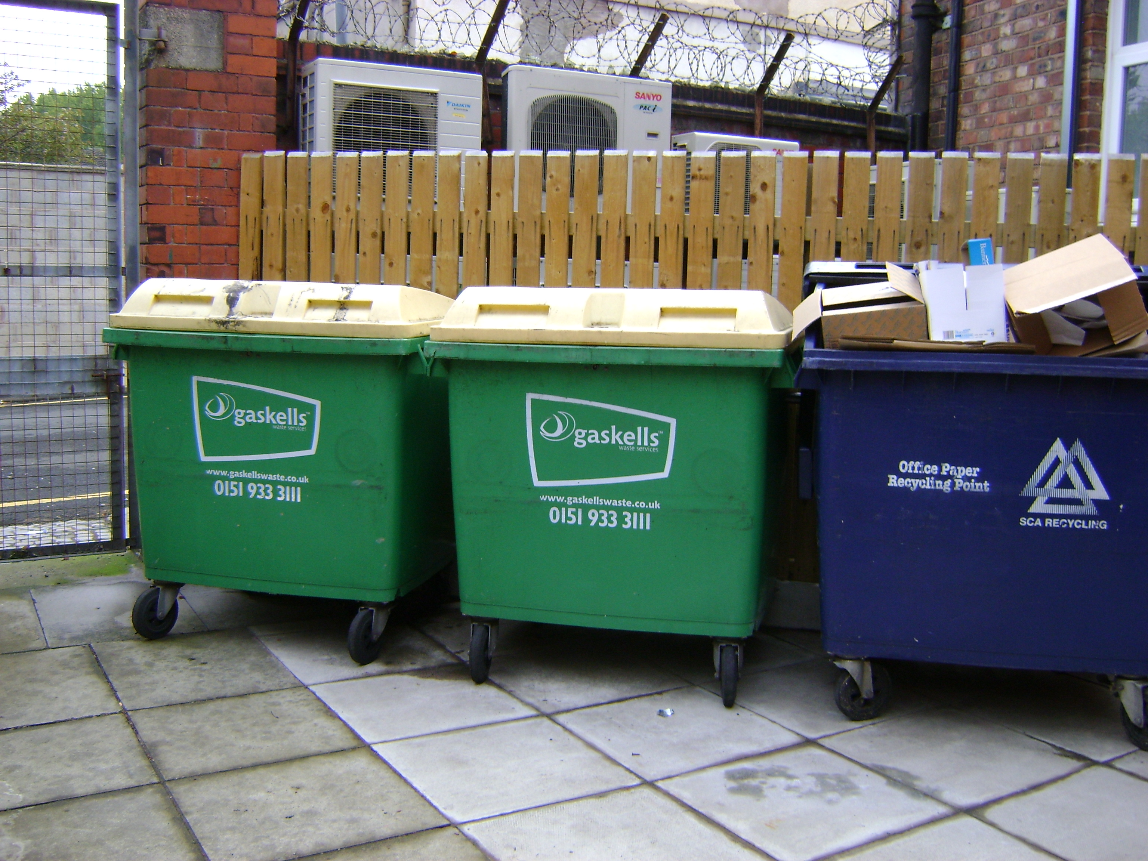
Checked.

Whose responsibility is this in your workplace?
.............................................................................................
Why should these areas be kept clean and tidy?
............................................................................................
............................................................................................
...........................................................................................
What PPE should be worn when handling waste?
....................................................................................................
Why is this important?
............................................................................................................................................................................................................................................................................................................

What procedures do you follow at your workplace for recycling?
......................................................................................................................................................................................................................................................................................................
Please list the items you recycle
......................................................................................................................................................................................................................................................................................................

Do you have any procedures in place for dealing with suspicious items?
............................................................................................................................................................................................................................................................................................................................................................................................................

Dealing with Routine waste
Some waste you deal with may be classed as clinical waste
Can you name the types of waste that come under this classification?
................................................................................................................................................................................................................................................................................................
What procedures do you follow for disposing of clinical waste?
........................................................................................................................................................................................................................................................................................................................................................................
Some waste you deal with may be classed as Hazardous waste
Can you name the types of waste that come under this classification?
................................................................................................................................................................................................................................................................................................
What procedures do you follow for disposing of Hazardous waste?
........................................................................................................................................................................................................................................................................................................................................................................

Why is it important to dispose of waste correctly?
..................................................................................................................................................................................................................................................................................................................................................................................................................................................................................................................................................

Dealing with Routine waste
Below are types of waste containers that you may or may not have in your workplace, can you list items that would go in each individual container and the correct PPE to be worn.

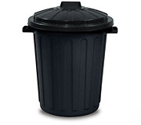
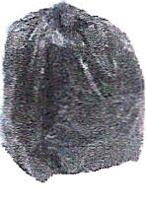

Name of container | Type of Waste | PPE to be worn

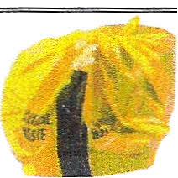
Name of container | Type of Waste | PPE to be worn

Dealing with Routine waste
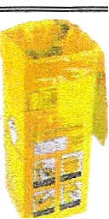
Name of container | Type of Waste | PPE to be worn

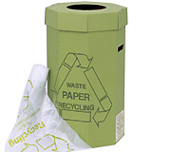

Name of container | Type of Waste | PPE to be worn

Dealing with Routine waste
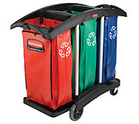

Name of container | Type of Waste | PPE to be worn

All waste bins/containers should be emptied and cleaned, relined on a regular basis all waste containers are breeding grounds for bacteria.
How often to you empty waste bins? .......................................................................................................
How often do you clean waste bins?
.......................................................................................................
What PPE do you wear? ..........................................................................................................

Pest Infestation
How can you identify signs of infestation? Below are some common facts on different types of pest that you may or may not come across in your workplace

Rats

Some Facts:
Rats are nocturnal and very intelligent that is why we have trouble controlling them. The Rat can climb, swim and move very quickly, they require lots of water to drink and a food source.
The Females can produce a litter of up to eight a month and the young can become sexually mature within three months. The results are that every pair of rats can produce up to a thousand in one year.

Some Facts:
Rats carry diseases by spreading harmful bacteria on their feet, fur teeth and excrement this can affect us all by food poisoning and dysentery. Rats and Mice carry salmonella in their stomachs and droppings. They can spread bacteria and viruses that can contaminate our food.

How would you identify signs of Rat or Mice infestation?
........................................................................................................................................................................................................................................Who would you report this to and why is this important?
....................................................................................................................
Rat bites can give us a fever.
Weil’s disease is an infection carried in the Rats urine which contaminates water. Weil’s disease causes flu like symptoms, muscle pain and Jaundice it can be fatal if not treated.
Mice carry Meningitis which can be spread by breathing in dust that is contaminated with the rodent’s urine or droppings.

Pest Infestation
Some facts
The Bluebottle is larger than the common fly. The Flies feet are covered in bacteria and this is how they manage to contaminate food.
As it feeds from decaying food the contamination is caused by the flies gut, feet, legs, excrement and by laying its eggs. The female can lay around 900 eggs and in the right temperature the eggs can develop and hatch in 10 – 48 hours so the warmer it is the quicker they will hatch.

Flies
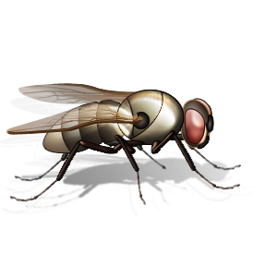
Some facts
Flies can transmit many diseases such as diarrhoea, diphtheria, typhoid dysentery and cholera.
There are several types of flies. Let us take a look at some them:
The common housefly and lesser housefly
The lesser housefly relies on living in the indoor climate and they like to fly around the lights, the female tend to lay their eggs in very damp material.

The flies moisten its food with vomit before they eat spreading bacteria wherever they land, Flies drop faeces whilst feeding dropping up to 100 time a day.

How would you identify signs of an infestation of Flies?
............................................................................................................................................................................................................................................................................................................................................................
Who would you report this to and why is this important?
....................................................................................................................
The life cycle of the fly is
Egg = Maggot = Pupa = Fly

Pest Infestation
Some facts
The black ant nest outdoors but their taste for sweet things encourage them to enter in doors searching for food and becoming pests, they are not known to spread disease however it does depend on where they have walked.

Ants
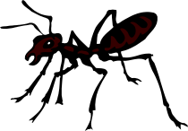
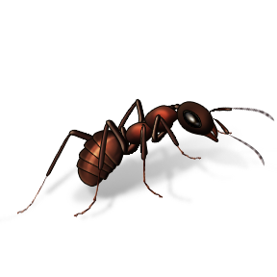
Some facts
There are two types of ants:
The Black garden ant and the Pharaoh ant.
The Black garden ants nest outdoors where as the Pharaoh ant lives indoors where humidity is high, the Pharaoh ant is small and yellowish red in colour.

Some facts
The Pharaoh ant on the other hand lives off protein foods like meat; they are known to carry diseases because of the dirty places they go. The Pharaoh ant very small size may prove to be extremely difficult to eradicate and you will need the help of a specialist.

How would you identify signs of an infestation of Ants?
............................................................................................................................................................................................................................................................................................................................................................
Who would you report this to and why is this important?
....................................................................................................................

The life cycle of the Ant is
Egg = Larva= Pupa = Ant

