Unit 223: Keep stock on sale at required levels in a retail environment
Handout 1: How to check the level of stock on sale

It is important that retailers carry the right amount of stock. Too much stock will mean they have invested capital that they did not need to. This can lead to:
- reduced profits
- a lack of available funds to order new stock
- increased wastage
- the need to reduce prices to clear overstocks.

Too little stock can also be a problem. Customers will be unable to buy the goods they want from you leading to lost:
- sales
- customer goodwill
- custom
- profit.

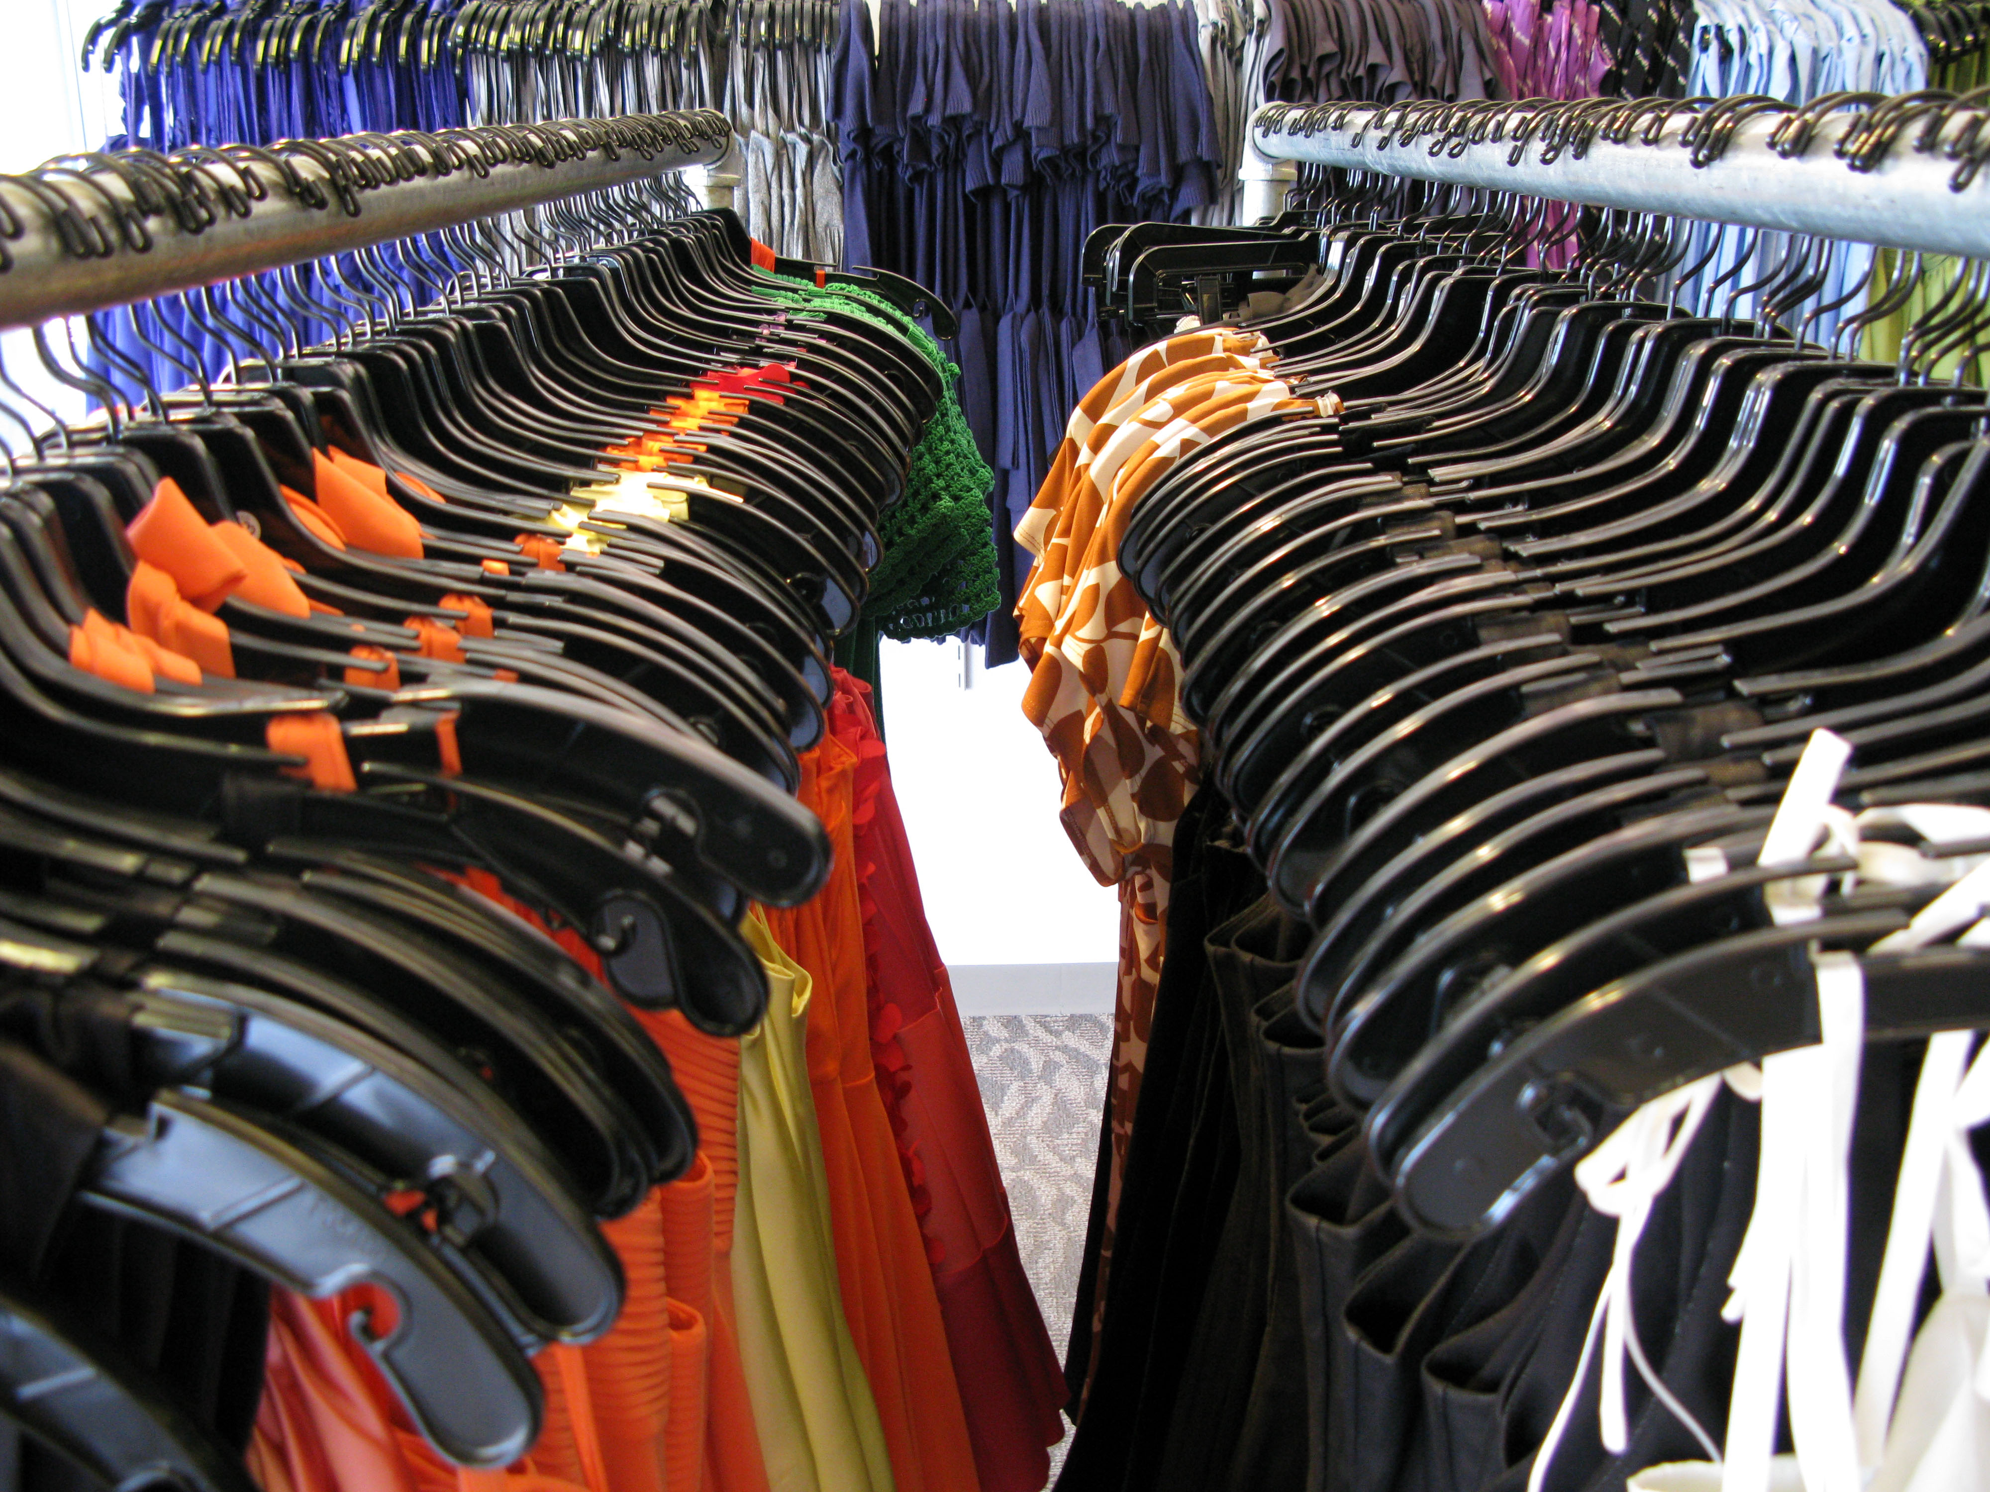
As well as having the correct level of stock available, it is important that the correct level is on display. Different items of stock will have been allocated amounts of space on the shelves or fixtures and this allocation should not be exceeded when filling up, as this would reduce the amount of space available for other stock. Stock should be replenished when the amount of stock on display falls to a level where there is a risk that customers may not be able to find the products they are looking for.

Demand
The demand for different types of stock will be affected by a number of factors including the time of day. Customers will be shopping for products such as newspapers, sandwiches, milk, jars of coffee or snack to eat at lunch time on their way to work or school in the morning; during the day customers will be doing their weekly shopping and towards the end of the day customers may be looking for a bottle of wine or some beer, a frozen meal or a lottery ticket.

Similarly, demand for stock will vary on different days of the week. Fresh fruit and vegetables will sell more towards the end of the week, for instance, while an approaching Bank Holiday will send the demand for barbecues and the types of food cooked on them sky high.

Because of this changing demand, it is important to get into a routine that enables you to check the right types of stock at the right time of day and at suitable intervals. You will need to plan and organise your time so that stock checking can be carried out when necessary.

Quality of stock
It is also important to check the quality of stock regularly. You will not be able to sell goods of poor quality. Customers will avoid damaged, old, out of date or tatty goods, so they may have to be reduced or written off and disposed of. Maintaining the quality of stock is as important as having the correct level of stock. If a retailer has a reputation for selling poor quality stock, many customers will not use it at all and those who do will expect low prices.

You will need to identify any stock that does not meet the standard of quality that your company expects. This may be because it has been damaged while on display or because it is approaching its ‘use by’ or ‘best before’ date. The rules state:

- you can sell food after its ‘best before’ date as long as you clearly inform the customer
- it is illegal to sell food after its ‘use by’ date.

Check the ‘use by’ and ‘best before’ dates as you check stock levels and reduce the price of stock nearing the deadline. Any stock past its ‘use by’ date or that has been damaged must be written off to correct the stock records and disposed of according to company procedures.

Use the stock control system to identify the stock that is available and to recognise where there may be shortfalls in the stock levels.

