Unit 231: Process payments for purchases in a retail environment
Handout 2: How to provide service at point of sale in a retail store

Types of payment
When providing service at the point of sale you will be responsible for receiving payment by a number of different methods:
- cash
- cheques
- credit cards
- debit cards
- charge cards.

You need to be familiar with your company procedures for accepting each of the above. All of these payments also need to be kept secure from theft.

Cash
As cash can be stolen from the till by customers, you should ensure that the drawer is closed as soon as possible during the transaction and that notes are removed from the till to a more secure place, such as a counter cache or the cash office, at regular intervals. Cash is also at risk from dishonest members of staff; never ‘borrow’ money from the till; ensure that company procedures are followed if any cash is to be taken from the till to fund petty cash purchases, etc.


Some shops will accept Scottish or Irish banknotes or even Euros. You need to know which, if any, you are authorised to accept and, in the case of Euros, where to find the correct exchange rate.

When accepting cash, many retailers will complete the transaction and count the change into the customer’s hand before placing the banknote in the till. This will avoid any dispute or confusion over the value of the banknote accepted. You must also check all banknotes to ensure that they are not counterfeit. If you have a detection pen or UV light, use this; if not, check for:
- watermarks
- metal strips
- raised print.

Cheques
Cheques are fairly uncommon in retailing nowadays. When accepting cheques, look for:
- words and figures agree
- signature agrees with supporting card or driving licence
- correct date
- correct payee’s name.

Credit, debit and charge cards
The major difference between the various types of card is the point at which the customer has to pay for the goods:
- credit cards; monthly statement, customer can pay in full or in part
- debit cards; money taken instantly from customer’s bank account
- charge cards; monthly statement, customer has to pay in full.

Credit cards, debit cards and charge cards are almost universally accepted using ‘chip and pin’ technology. This means the card is inserted into a reader which is connected electronically to the card issuer; the customer enters a PIN number and the reader automatically authorises the transaction. There are still a small number of cards and customers not using this technology; you need to know your company’s procedures for dealing with these.
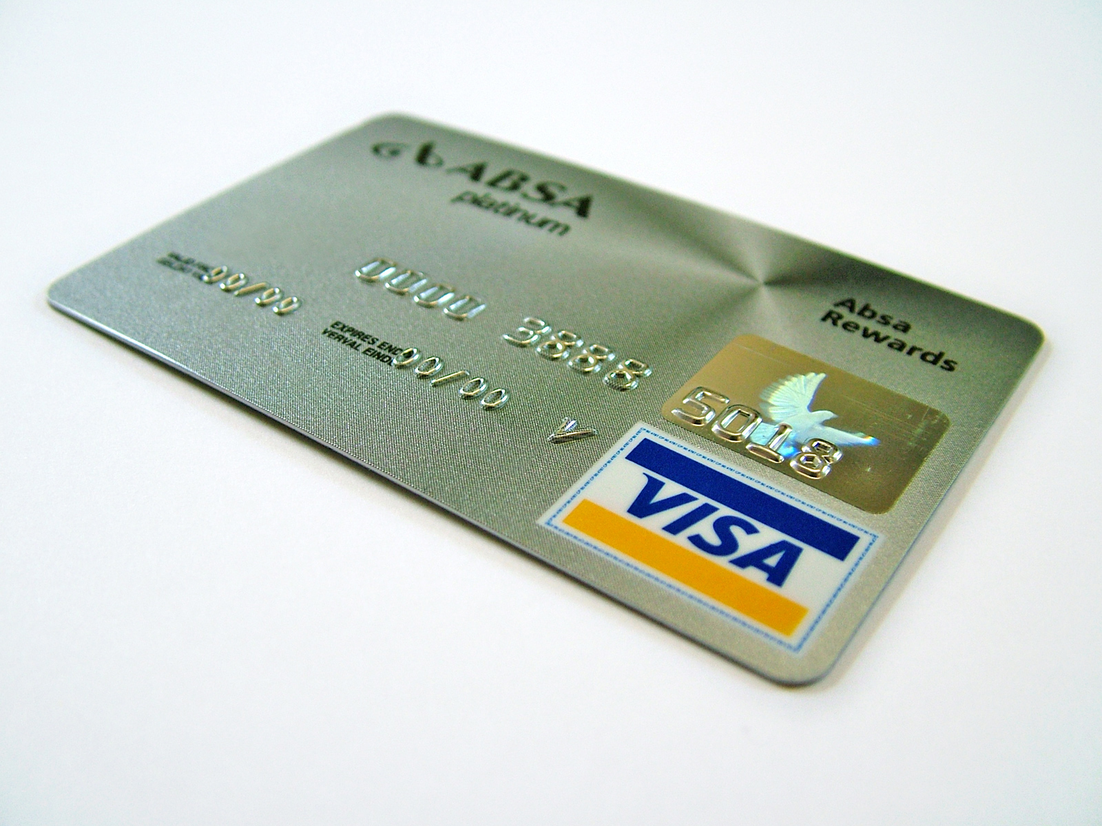
An additional service that is offered by many retailers to customers paying by debit card is a ‘cash back’ service. Customers are allowed to take cash by increasing the amount charged to their debit card. For instance a customer may make a purchase of £100 and request £50 in cash. The cashier would give the customer the £50 and charge £150 to the customer’s debit card. This facility, in addition to being good customer service, reduces the amount of cash held in the store, reducing the security risk and the amount of cash to be banked, reducing the charge to the store made by the bank for accepting cash.

Dealing with suspect payments
It is important that you know and understand your company procedures for dealing with suspect payments. If you are given a banknote that appears to you to be counterfeit based on making the normal checks, you must tell the customer that you believe the note to be counterfeit and ask them for another form of payment. The suspect note must not be returned to the customer, as it is a criminal offence to hold or to pass on a note which you know to be counterfeit. The customer’s name and address should be taken and the note forwarded to The Bank of England who will decide on its authenticity. If the note is found to be genuine, The Bank of England will compensate the owner.

If a customer offers a cheque which does not pass the checks listed above, you will need to refuse the cheque and request another form of payment. Similarly, if a card fails to authorise, payment by cash or another card should be requested. In all of these circumstances, the customer should be advised discreetly and politely that there is a problem without other customers’ attention being drawn to the issue.

If you have reason to suspect that a cheque or card offered to you in payment is stolen or that the customer is attempting to commit fraud, follow your company procedures for alerting a supervisor or the security staff, being careful not to put yourself at risk either of violence or of a charge of defamation from a genuine customer by making public accusations.

