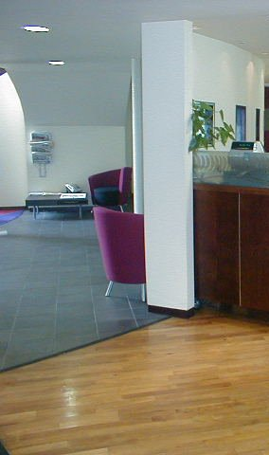

CLEANING BUILDING INTERIORS

Support Material for N/SVQ’s Level 2

Additional reference material will be required to complete this unit in full:

C REDUCE RISKS

F WASTE DISPOSAL

L CONTROL THE USE OF RESOURCES

Please use the space below to make your own notes:

This reference material will provide you with the following knowledge and understanding.

Prepare to clean floors manually:

- How to assess the risk to yourself and others

- How to assess cleaning methods

- How to pick up large items of litter

- How to move easily lifted furnishings

- How to remove sticky solids

Manually clean floors

- How to dry mop floors

- How to brush sweep floors

- How to brush scrub floors

- How to damp mop floors

- How to remove spillages from floors

- How to suction clean floors

- What the approved procedures are for ordering resources, and why it is important that these are followed

Complete floor cleaning

- How to leave the area after cleaning

- How to dispose of waste

- How to clean and store away equipment and materials

- How the effective use of resources can benefit the organisation as a whole

- Why it is important to return unused and re-usable resources to the right place(s), and where these places are

HOW YOU SHOULD PREPARE TO CLEAN FLOORS MANUALLY

Before using any Tools or Equipment, the cleaner must understand the contents of the following sections of this reference material:
A: Health & Safety, B: Identify Hazards & Security, C: Reduce Risks

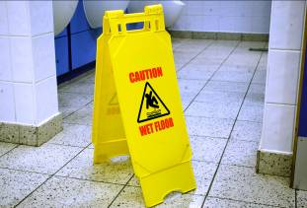 | - Consider the risks to self and others
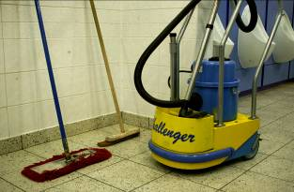 | - Decide the best method to clean the floor
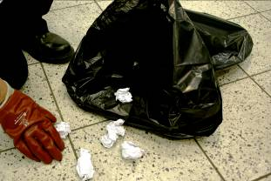 | - Pick up large items of litter
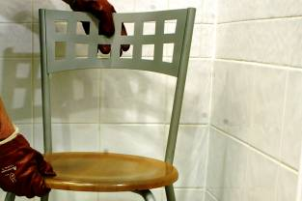 | - Move furniture and other moveable objects
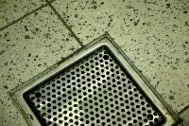  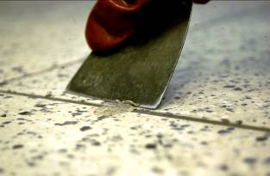 | - Check/report damage  - Remove sticky solids
WHAT YOU SHOULD KNOW ABOUT PREPARING TO CLEAN FLOORS MANUALLY
- Thinking of the risks before starting a job helps to avoid creating dangerous situations
- See sections B: Identify Hazards & Security, C: Reduce Risks
- Consider each of the following:
- Floor type
- Type of soil and dirt
- Amount of dirt
- Tools and equipment available
- Time available
- This avoids large items becoming trapped in mops and brushes, and scratching or damaging the floor
- Litter can block suction cleaners and can damage brushes and beater bars on suction sweepers
- If possible, draw a small plan/map of furniture positions to help with correct replacement when cleaning is finished
- Dust builds up around and under furniture
- Removing dirt from underneath objects:
- Prevents this dirt from being transferred to clean areas
- Gives the customer a good impression of the standard of cleaning carried out
- Always use SAFE MANUAL HANDLING technique.
- See section C: Reduce Risks
- Before starting to clean check floor for any visible damage e.g.
- Nails and screws sticking out of the floor will damage mops and brushes passing over them
- Splintered wood, broken tiles, torn vinyl or linoleum can be further damaged by cleaning; they also present a trip hazard
- Report damage to your supervisor before starting to clean so that repairs can be carried out
- DO NOT knock down nails or drive the head of screw below the floor level, as this could damage pipes or fittings beneath the floor.
6
- Chewing gum or sticky items could be picked up on shoes and transferred to other areas
- These could stick to the mop and make cleaning difficult
- Scraping is the easiest way of removing sticky items from hard floors

HOW YOU SHOULD MANUALLY PASS DRY MOPS OVER FLOORS

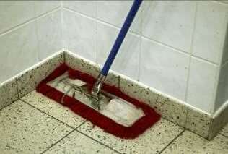 | - Mop edges and corners
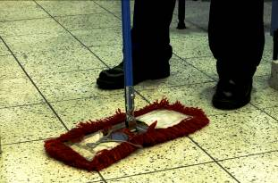 | - Begin at furthest point from the exit
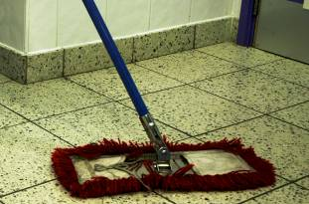 | - Work on small sections when covering large areas
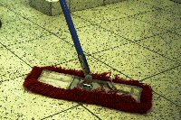 | - Work with a continuous pass
 | - Overlap the previous pass on each turn
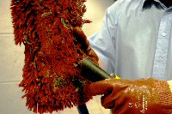 | - Check mop frequently

WHAT YOU SHOULD KNOW ABOUT MANUALLY PASSING DRY MOPS OVER FLOORS
- Always mop edges and corners first
- Always keep mop head in contact with the floor to stop dust/dirt rising into the air
- Use one side of mop as the leading edge to collect dust
- Use a dust pan and brush to sweep corners, as these are difficult to clean with a swivel headed mop
- This prevents having to walk over an already cleaned part of the floor to reach the exit
- This reduces the amount of movement and makes overlapping easier
- Do not overreach yourself as this leads to twisting and back injury
- This gathers dust on the leading edge of the mop
- Swivel headed mops should be used in a figure of eight or snaking pattern
- DO NOT use a broom sweeping action, as this causes dust to fall out of the mop into the air
- If hard brushing, use a pushing action and short strokes
- This ensures no part of floor is missed
- Do not over-reach as this can cause back injury
- Move feet to prevent over-reaching
- Large areas may require the mop head to be cleaned or changed more often
- Use a suction cleaner to remove dust from the mop head

HOW YOU SHOULD DRY MOP SWEEP SEMI HARD AND HARD FLOORS MANUALLY

1
- Carry out preparation tasks

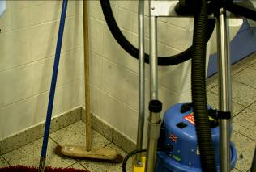 | 2  - Select the mop to suit the floor type and task
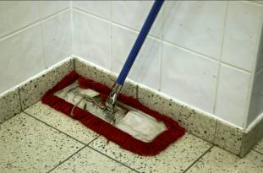 | 3  - Mop edges and corners
4
- Mop dirt into piles for removal

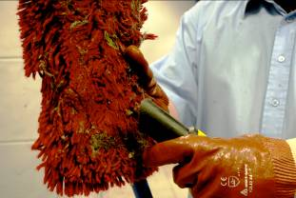 | 5  - Check mop frequently
6
- Complete manual cleaning of floor

WHAT YOU SHOULD KNOW ABOUT DRY MOP SWEEPING SEMI HARD AND HARD FLOORS MANUALLY

- See Section 'How You Should Prepare to Clean Floors Manually’
- Swivel headed mop for greater control
- V mop for large areas, as this reduces the cleaning time
- Push the mop so the head forms an angle that moves dirt away from skirting boards
- Always keep the mop head in contact with the floor to stop dust/dirt rising into the air
- Use one side of mop as the leading edge to collect dust
- Use a dust pan and brush to sweep corners, as these are difficult to clean with a swivel headed mop
- Pick up dirt when the amount gathered becomes difficult to mop without losing some out of the side of the brush head
- Use a long handled dustpan to reduce the need to bend, which can lead to back injury
- Or use a shovel or suction cleaner
- Place waste in collection bag.
- See Section G: Colour Coding
- Large areas may require mop head to be cleaned or changed more often
- Use a suction cleaner to remove dust from mop head
- See section ‘How You Should Complete Manual Cleaning of Floors’

HOW YOU SHOULD BRUSH SWEEP SEMI HARD AND HARD FLOORS MANUALLY

 | - Carry out preparation tasks
 | - Select the brush to suit the floor type and task
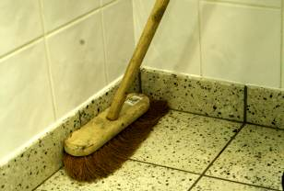 | - Sweep edges and corners
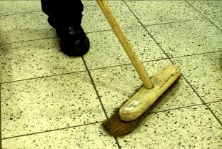 | - Sweep main floor
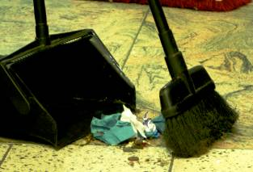 | - Sweep dirt into piles for removal
 | - Complete manual cleaning of floor

WHAT YOU SHOULD KNOW ABOUT BRUSH SWEEPING SEMI HARD AND HARD FLOORS MANUALLY
- See Section 'How You Should Prepare to Clean Floors Manually'

- Stiff bristles for rough hard floors and soft floors with heavy soil
- Soft bristles for smooth hard floors or when removing fine dust
- Pulling the brush places the head at an angle that moves dirt away from skirting boards
- Pushing the brush forces dirt in towards skirting boards
- Do not over-reach, as this can cause back injury
- Move feet to prevent over-reaching

- Push the brush with short repeated strokes gathering dirt together as you move behind the brush
- DO NOT walk behind the brush in a single long pass
- This causes dirt to move through the bristles and fall out of the back or sides of the brush
- DO NOT try to make the dirt move further ahead than the distance the brush head moves.
- This causes dust to rise into the air and scatters the dirt over a wide area

- Pick up dirt when the amount gathered becomes difficult to sweep without losing some out of the side of the brush head
- Use a long handled dustpan to reduce the need to bend, which can lead to back injury
- Or use a shovel or suction cleaner
- Place waste in collection bag.
- See Section G: Colour Coding

- See section ‘How To Complete Manual Cleaning of Floors’

HOW YOU SHOULD BRUSH SCRUB SEMI HARD AND HARD FLOORS MANUALLY

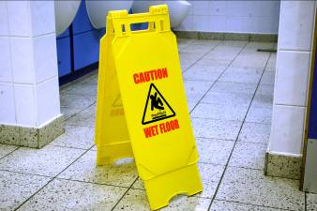 | - Carry out preparation tasks
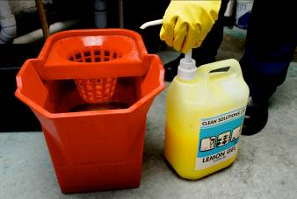 | - Select and prepare the solution
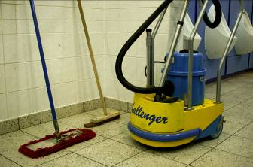 | - Select the brush and equipment
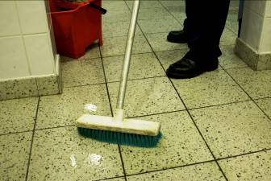 | - Apply the solution
 | - Pass scrubbing brush over floor
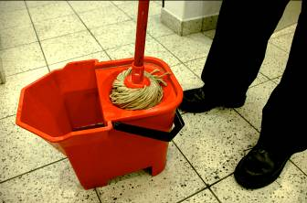 | - Remove solution
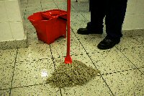 | - Complete manual cleaning of floor

WHAT YOU SHOULD KNOW ABOUT BRUSH SCRUBBING SEMI HARD AND HARD FLOORS MANUALLY
- See Section 'How To Prepare to Clean Floors Manually'
- See section D 'Cleaning Agents' and E 'Solution Mixing' for further information
- Choose a solution to suit the floor and area.
- See section E: Solution Mixing
- Long handled scrubbing brushes reduce kneeling
- Use hand scrubbing brush for difficult to reach areas
- Use a second bucket to collect dirty solution
- DO NOT choose stiff scrubbing brushes to scrub semi-hard floors, as this could damage the floor
- See section N2: Tools and Equipment To Clean Floors Manually
- Wet the brush and lightly shake excess solution back into the bucket
- Scrub the floor with the brush
- DO NOT over-wet the area, as this wastes the cleaning solution and does not clean any better
- DO NOT under-wet the area, as this can make it more difficult to clean the surface
- DO NOT scrub semi-hard floors too hard, as this can damage the floor
- See section ‘How You Should Damp Mop Hard and Semi-Hard Floors’
- Start at the furthest point from the exit
- Make sure scrubbing overlaps
- Overlapping prevents areas of the floor being missed
- Pay particular attention to heavy traffic areas e.g.
- Doorways, entrances
- Parts of the floor used as pathways
- Mop up solution with a wrung-out mop or floor cloth
- Leave the floor as dry as possible to reduce the chance of people slipping on the cleaned floor
- Remove all smears to give the floor a good appearance that will satisfy the customer
7
- See section ‘How To Complete Manual Cleaning of Floors’

HOW YOU SHOULD MANUALLY PASS DAMP MOPS OVER FLOORS

 | - Start at furthest point from exit
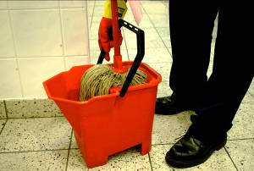 | - Apply the solution
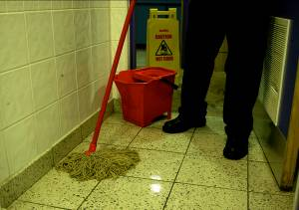 | - Start cleaning at the edges
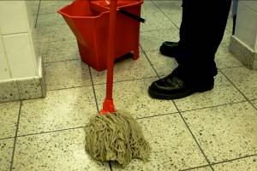 | - Work in continuous strokes
 | - Overlap each pass
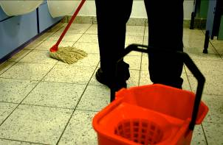 | - Work on small sections when covering large areas
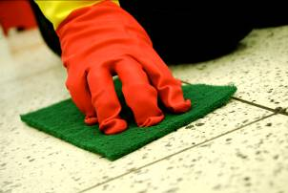 | - Rub stubborn marks
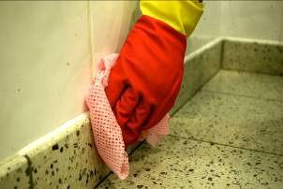 | - Wipe splashes from skirting boards as they occur

WHAT YOU SHOULD KNOW ABOUT MANUALLY PASSING DAMP MOPS OVER FLOORS
- This stops you from walking on cleaned areas as you move towards dirty areas or the exit
- Wet the mop, lightly wring and transfer solution to the floor
- DO NOT over-wet the area, as this wastes the cleaning solution and does not clean any better
- DO NOT under-wet the area, as this can make it more difficult to clean the surface
- ‘Cut in’ edges parallel to skirting boards before mopping the rest of the floor
- Pay close attention to corners where dirt tends to collect
- Clean edges show that you have done a thorough job and make a good impression on the customer
- Cover the area using a regular pattern without lifting the mop off the floor
- Figure of eight or snaking patterns are good
- Overlapping each pass prevents small areas of the floor from being missed
- This reduces the amount of movement and makes overlapping easier
- Do not over-reach yourself, as this leads to twisting and back injury
- Make a scrubbing action with the mop
- Select an abrasive pad that will not damage the floor
- Place abrasive pad under mop head
- DO NOT put too much pressure on the abrasive pad, as this could damage the floor
- This prevents:
- Splashed dirt or cleaning agent drying on the skirting boards and being difficult to remove
- Damage to skirting material or paint finish by cleaning agents/chemicals

HOW YOU SHOULD MANUALLY DAMP MOP HARD AND SEMI-HARD FLOORS

 | - Carry out preparation tasks
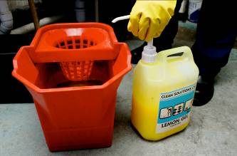 | - Select and prepare the solution
 | - Select the mop and equipment for the task
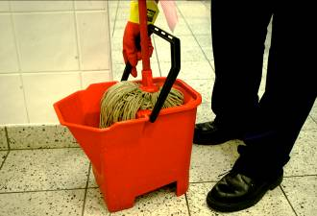 | - Apply the solution
 | - Pass mop over floor
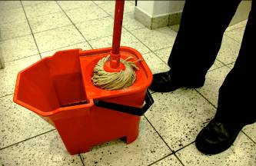 | - Wring out mop
 | - Rinse floor if required

WHAT YOU SHOULD KNOW ABOUT MANUALLY DAMP MOPPING HARD AND SEMI-HARD FLOORS
- See Section 'How To Prepare To Clean Floors Manually'
- See section E: Solution Mixing
- Choose a solution to suit the floor and area.
- Standard mops for any floor
- Flat sponge mops for smooth floors
- Use a second bucket to collect dirty solution
- See section N2: Tools & Equipment To Clean Floors Manually
- Wet the mop, lightly wring and transfer solution to the floor
- DO NOT over-wet the area, as this wastes the cleaning solution and does not clean any better
- DO NOT under-wet the area, as this can make it more difficult to clean the surface
- See section ‘How To Manually Pass A Damp Mop Over Hard Floors’

- Using a second bucket for wringing will help keep solution clean
- Or change dirty solution regularly
- Use the second colour coded mop and the unit containing the clean rinse water
- Change the rinse water frequently
- This prevents solution drying on floor and leaving marks

HOW YOU SHOULD MANUALLY DAMP MOP HARD AND SEMI-HARD FLOORS (continued)

- Remove solution or rinse water

- Complete manual cleaning of floor

WHAT YOU SHOULD KNOW ABOUT MANUALLY DAMP MOPPING HARD AND SEMI-HARD FLOORS (continued)

- Mop up solution/rinse water with mop after wringing
- Leave floor as dry as possible to reduce the chance of people slipping on the cleaned floor
- Remove all smears to give the floor a good appearance that will satisfy the customer
- See section ‘How You Should Complete Manual Cleaning of Floors’

HOW YOU SHOULD REMOVE SPILLAGES FROM FLOORS

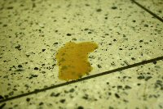 | - Identify the spillage and floor type
 | - Pick up solid items
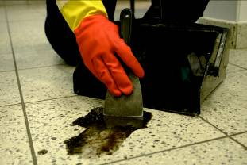 | - Remove semi solids
 | - Remove water based spills
 | - Remove body fluids

WHAT YOU SHOULD KNOW ABOUT REMOVING SPILLAGES FROM FLOORS

- See section N3: Types Of Floors
- Spillages can be:
- Water based. e.g. rainwater, burst pipes
- Food and drink e.g. meals, crumbs, tea, coffee, juice
- Semi solids e.g. wet sludge
- Body fluids e.g. blood, urine, faeces, vomit
- DO NOT attempt to clean any spillages that you cannot identify; they could be harmful and need special treatment
- Report unidentified spillages to your line manager who can then decide what action to take
- Use a dustpan and brush or tongs
- Work from the outside edges of the spillage towards the centre. This prevents the spillage from being spread
- Place into suitably coloured waste bin.
- See section G: Colour Coding
- Suction clean
- Use a scraper or squeegee to collect spillage
- Work from outside edge towards centre of spillage to prevent it spreading
- Scoop onto a shovel or soak up with absorbent cloths or paper
- Place into suitably coloured waste bin.
- See section G: Colour Coding
- Use mop or absorbent cloth and wring into a bucket
- Use squeegee to collect spillage
- Work from outside edge towards centre of spillage to prevent it spreading
- Leave floor as dry as possible to prevent people slipping on the surface
- ALWAYS protect yourself from the possibility of infection.
- See section B: Identify Hazards & Security, and C: Reduce Risks
- Treat these spillages as liquid and semi-solid spills
- Work from outside edge towards centre of spillage to prevent it spreading
- Place waste in suitably coloured waste bin.
- See section G: Colour Coding
- Apply a Virucidal or Bactericide solution to the spillage area to kill germs. This reduces the chance of spreading infection and gets rid of unpleasant smells.
- See section E: Solution Mixing

HOW YOU SHOULD REMOVE SPILLAGES FROM FLOORS (continued)

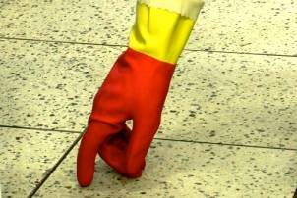 | - Check for stains
 | - Complete manual cleaning of floor

WHAT YOU SHOULD KNOW ABOUT REMOVING SPILLAGES FROM FLOORS (continued)
- Report any stains to the supervisor
- The supervisor can then decide to instruct a cleaner to spot clean the stains immediately, or make arrangements with the customer for the job to be completed at a more convenient time.
- This indicates to the customer that you have identified that additional cleaning is required and that your company is seeking approval to carry out the task. This is good customer care.
- See section ‘How To Complete Manual Cleaning of Floors’

HOW YOU SHOULD SUCTION CLEAN FLOORS

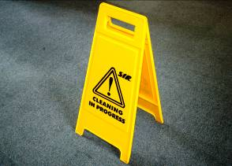 | - Carry out preparation tasks
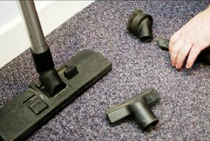 | - Decide which attachments to use
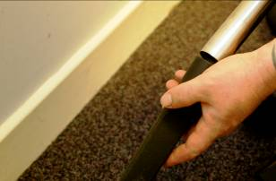 | - Fit and adjust attachments
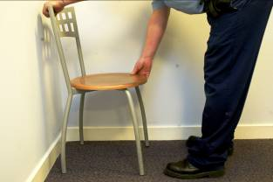 | - Move furniture and other moveable objects
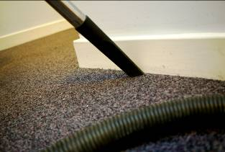 | - Clean edges and corners
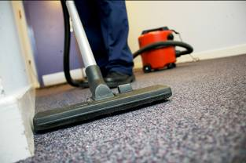 | - Pass over the floor
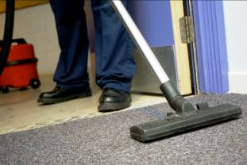 | - Complete manual cleaning of floor

WHAT YOU SHOULD KNOW ABOUT SUCTION CLEANING FLOORS

- See Section N2: Tools & Equipment To Clean Floors Manually
- Consider each of the following:
- Floor type. Hard floors should NOT be cleaned with beater bars
- Type of soil and dirt
- Amount of dirt
- Tools and equipment available.
  - See section N2: Tools and Equipment To Clean Floors Manually
- Connect hoses and brushes
- Set height of cylinder brushes and beaters e.g.
- Carpet set to match length of pile
- Vinyl, wood or quarry tiles high setting
- Dirt builds up around and under furniture
- Removing dirt from underneath objects:
- Prevents this dirt from being transferred to clean areas
- Gives the customer a good impression of the standard of cleaning carried out
- Always us SAFE MANUAL HANDLING technique.
- See section C: Reduce Risks
- Use attachments to:
- Clean edges and corners
- Clean under furniture that can't be moved
- Reach areas not accessible with the machine
- Some suction cleaners may not clean up to skirting boards and into corners without attachments
- Start at the furthest point from the exit
- Making sure passes overlap
- Where possible, vacuum against the pile of the carpet (if it has one) in order to lift the loose dirt out of it
- Pay particular attention to heavy traffic areas e.g.
- Doorways, entrances
- Parts of the floor used as pathways
- See section ‘How You Should Complete Manual Cleaning of Floors’

HOW YOU SHOULD COMPLETE MANUAL CLEANING OF FLOORS

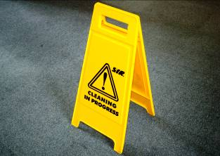 | - Allow floor to dry if applicable
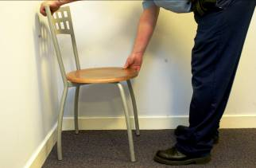 | - Replace furniture and other moveable objects
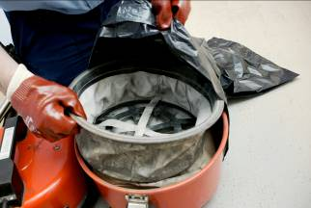 | - Clean equipment and return it to store

WHAT YOU SHOULD KNOW ABOUT COMPLETING MANUAL CLEANING OF FLOORS

- Avoid replacing furniture before the floor is completely dry
- This prevents marks and smears from walking, or dragging furniture over a damp floor
- If floor cannot be left until completely dry, place pieces of cardboard or plastic under furniture feet/legs. This stops dampness from being absorbed into furniture legs
- Return to original position using your map/plan if drawn
- Customer could be disappointed by incorrect positioning
- Always us SAFE MANUAL HANDLING technique.
- See section C: Reduce Risks
- Dispose of waste.
- See section F: Waste Disposal
- Cleaning equipment means it is immediately ready to be used next time, and helps in identifying faulty items
- Rub bristles over waste bin to remove dust
- Wash or replace mop head if necessary
- Hang mop/brush with head up
- This allows air to circulate through mop/bristles and helps to dry and remove odours
- Report any damaged or faulty equipment to your supervisor e.g.
- Broken mop heads
- Bristles falling out of broom heads
- Splintered mop handles
- These can then be repaired/replaced prior to next scheduled cleaning

CHECK WHAT YOU KNOW ABOUT CLEANING FLOORS MANUALLY

Circle the correct answer to the following questions:

Why is it important to keep a dry mop clean?
- It will not work properly if not kept in a clean, dry condition.
- It does not matter, as it works just as well clean or dirty.
- It will only get dirty again.
- Nobody bothers, as long as the floors look clean.

Why must you keep a dry mop in contact with the floor at all times with a leading edge?
- It can be used like a brush so it is not important.
- To clean the floor correctly, picking up all dust.
- So that it can be used on wet floor areas.
- It looks better and is safer.

Why should a suction cleaner be used to clean the dry mop head?
A It is the cleanest and most efficient way to remove all dust.
B It does not matter; it can be cleaned by cleaned by giving it a few hard knocks on the floor.
C Standing it up and cleaning it by hand or a stiff brush is best.
D It takes too long to get a suction cleaner out.

Why is it important to plan how you will damp mop a floor?
A So that you cover the floor methodically and do not have to walk on a damp floor.
B There is no time for planning, just clean as best as you can.
C Walking over a damp mopped area is safe if you take care.
D You do not have to think of other people as the job has to be done.

CHECK WHAT YOU KNOW ABOUT CLEANING FLOORS MANUALLY (continued)

To damp mop correctly why must the mop be well rung out?
A A wet mop works better.
B It does not make any difference.
C It is more important to have plenty of chemical in the solution.
D A damp mop used correctly picks up the dirt best.

Why is it important to identify the nature of spillage on a floor before cleaning?
A All spillages are cleaned the same way, so it does not matter.
B Some spillages may be harmful and correct methods must be used.
C The same equipment is used for all spillages.
D Cleaners are not trained to identify spillages.

Before using a suction cleaner, why should it be checked correctly?
A To ensure that the machine works correctly and safely.
B It does not matter if it works.
C Another cleaner used it yesterday, so it should be OK.
D We use tub-vacs and they do not require checking.

How would you remove dried-in dirt from carpets?
A Use pressure on the floor tool of the suction cleaner.
B Dampen the dirt before using the dry suction cleaner.
C Use a stiff brush to slacken the dirt before suction cleaning.
D Leave it, as there is not enough time.

What would you check for before cleaning a hard floor?
A That large waste objects have been picked up and chewing gum scraped free.
B The colour of the floor.
C That you have enough time.
D That you are wearing your overalls



© B-Skill Ltd.
Permission to reproduce this material must be obtained from:

B-Skill Limited
Chaucer Buildings
57 Grainger Street
Newcastle upon Tyne
NE1 5JE

Tel: 0845 230 3736
Fax: 0845 230 4634

Designed in conjunction with Award Learning Services Ltd, Chelmsford

