UNIT 1: Prepare yourself to deliver good customer service

This unit is all about how your organisation works, what it does and where you fit into it.

DEFINING CUSTOMERS

Customers are the life-blood of any organisation however big or small it may be. This NVQ qualification is all about providing good customer service, so who exactly are your customers and what is their role in your organisation?
A customer is anyone to whom your organisation offers a product or service. Customers fall into two categories: external and internal customers.
External customers are the people you meet from outside your organisation who come to you for services and products. They’re the people you meet day to day or talk to over the phone or interact with via post or email. They are crucial to any organisation and usually provide most of your organisation’s income.
Internal customers are those individuals within your organisation who need you to provide them with products, services and support to ensure the smooth running of the business. They are as important as external customers so it’s equally important that you treat them with the same level of customer care as external customers. Your relationship with them will probably be a two-way relationship i.e. : you will support each other with assistance and help as part of your daily job.

DEFINING CUSTOMER SERVICE
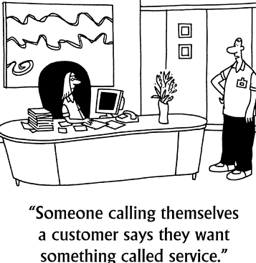
To provide high quality customer service you need to:
- Fully understand how your organisation operates. Which members of staff are responsible for which duties? If you have a good understanding of staff members’ roles and responsibilities you’ll be better able to help both customers and colleagues on a daily basis.
- Fully understand your own role and job description. What is expected of you? How are you expected to handle your customers’ needs?
- Fully understand the good and services that your organisation offers. Do you know what these services are? Can you pass on this knowledge to customers in a simple effective way?

YOUR ORGANISATION: ITS STRUCTURE, PRODUCTS and SERVICES

1. STRUCTURE
You need to understand how your organisation operates and exactly what it does. If you understand the structure of your organisation, you will know how many departments there are within it and what each of these departments does and what each is responsible for.
If you work for a very big organisation with hundreds of different departments you will not be expected to know what each department does BUT you MUST know who you should refer customers to within the organisation for any query or concern that they might have.

2. PRODUCTS and SERVICES
Do you have a good understanding of the products or services you deal with? Do you know the features and benefits of each of your products/services? YOU SHOULD…
For each of the products and services offered by your organisation, try to think of the features and benefits that apply. Gather information about them whenever you can and keep this information updated and close to hand. If you can respond to any customer enquiry with knowledge and understanding, you will be offering the standard of customer service they expect and deserve If you’re asked a question you don’t know the answer to, don’t worry, be honest but make sure you know the next step you should take to ensure the customer receives the information they’ve requested.

3. WHAT IS GOOD CUSTOMER SERVICE?
Once you’ve equipped yourself with a full understanding of your organisation, how it works and the services or products it offers you need to make sure that your can provide the appropriate customer service.

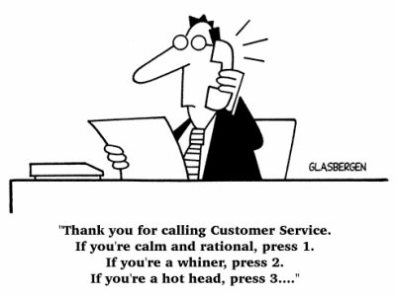

Customer Service is the service you yourself would expect to receive if you were an external customer.
It’s the service you provide before, during and after the customer has bought or used your services or products. It is a level of service that exceeds your customers’ expectations. It is about going beyond the call of duty and ensuring that any individual you deal with either face-to-face, over the phone or via post or email is delighted by the service they received from you.
GOLDEN RULES
1) Answer your phone.  2) Don’t make promises unless you WILL keep them.  3) Listen to your customers.  4) Deal with complaints. |  | 5) Be helpful - even if there’s no immediate profit in it.  6) Get trained or train your staff (if you have any) to be  ALWAYS helpful, courteous, and knowledgeable.  7) Take the extra step.  8) Throw in something extra
4. Customer Expectations And Customer Satisfaction
Customers feel satisfied when the service and the behavior they receive meets their needs and exceeds their expectations. In order for customer satisfaction to take place each of the following needs must be met or exceeded:
The service or product: the quality of the service or product provided must meet the requirements of the customer.
The behaviour of everyone in the organization who deals with the customer makes a major impact on influencing customer satisfaction (or dissatisfaction).
The customers’ needs and expectations need to be exceeded to ensure a satisfied customer. A customer who merely has their needs met normally has no strong feelings about the quality of service (it is neither good nor bad). When service does not meet the needs of the customer then they will feel dissatisfied.

Now. Try this missing words puzzle
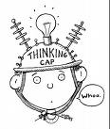
* * * * * You will find the missing words at the foot of the page.
They will all come in handy in completing the activities in this workbook * * * * *
1. Know your product - Know what products/service you are offering back to front. In other words be an ן__ן__ן__ן__ן__ן__ן__ן__ן__ן__ן__ן ן__ן__ן__ן__ן__ן__ן. If you have to say you don’t have the answer to a query it should always be followed up by: "but I’ll ן__ן__ן__ן__ן ן__ן__ן__ן" and something like: " I’ll ן__ן__ן__ן__ן__ן__ן__ן__ן__ן__ן get back to you within the hour".
Whatever the situation may be, make sure that you leave your customer ן__ן__ן__ן__ן__ן__ן__ן__ן__ן that you have the matter in hand and that you are committed to their ן__ן__ן__ן__ן__ן__ן__ן__ן__ן__ן__ן__ן.
2. Body Language - Most of the ן__ן__ן__ן__ן__ן__ן__ן__ן__ן__ן__ן__ן__ן that we have with others is done through body language such as gestures, ן__ן__ן__ן__ן__ן__ן ן__ן__ן__ן__ן__ן__ן__ן__ן__ן__ן__ן and stance. If we have a ן__ן__ן__ן__ן__ן__ן__ן__ן body language when we interact with others it can show our lack of ן__ן__ן__ן__ן. Two of the most important ן__ן__ן__ן__ן__ן__ן__ן__ן parts of body language are smiling, and ן__ן__ן__ן.- ן__ן__ן__ן__ן__ן__ן__ן. Make sure to look your customers in the eye. It shows that we are ן__ן__ן__ן__ן__ן__ן__ן__ן__ן to them, not at them. And then smiling of course is just more ן__ן__ן__ן__ן__ן__ן__ן__ן__ן than someone who has a blank look on their face.
3. Anticipate Customer Needs - Nothing surprises your customer more than an employee going the ן__ן__ן__ן__ן__ן ן__ן__ן__ן__ן to help them. Always look for ways to ן__ן__ן__ן__ן__ן your customer more than they expect. In doing so it helps them to know that you care and it will leave them with the "Feel ן__ן__ן__ן__ן Factor" that we are searching for.

care
communication
confident
definitely

extra mile
eye-contact
facial expressions
find out

Good
Information expert
inviting
listening

negative
positive
satisfaction
serve
smiling

5. THE REPUTATION OF YOUR ORGANISATION AND ITS BRAND
By delivering excellent customer service, you are personally contributing to the reputation of your organisation.
If your organisation’s products are of a high standard AND every member of staff delivers an excellent standard of customer service AND you exceed each customer’s expectations you will be rewarded with a satisfied customer and SATISFIED CUSTOMERS ARE RETURNING CUSTOMERS!
Whatever position you hold, all of your actions will in some way affect how each and every customer feels about the business. If you fail to provide an appropriate level of customer service, your organisation will suffer. Research has shown that unhappy customers will tell 9 other people about the inadequate service they received. Those 9 people will then pass this message onto another 4 people. Within a short space of time, 36 people will have received negative feedback about your organisation.
Every day you can help to build your organisation’s reputation by :
- Being reliable.
- Having a good knowledge and understanding of your organisation’s products and services, and passing this information on to customers in a helpful friendly manner.
- Showing understanding and always treating customers fairly.
- Consistently providing an excellent level of customer care.
- Delivering goods and services on time.
- Being friendly, welcoming and polite to every customer.
- Listening to your customers so that you really understand their needs.

Once you’ve really read through this unit and fully understand customer service – what it is, why it’s essential in any successful business and how you can apply a level of excellence to the customer service that you provide - you’re ready to complete the assessment activities that follow.
UNIT 1 Assessment Activities
This unit is all about how your organisation works, what it does and where you fit into that.
You need to know how your organisation works to provide good customer service. This means understanding who does what and being able to explain it to customers or colleagues. It also means you must understand what your role is within the organisation and what is expected of you. Each organisation offers a different package of products and services to its customers so you must understand and be able to explain what yours offers.
Key words and phrases for this unit:
• what the organisation does
• types of customers
• know where to find help
• give information
• receive information
• build a reputation
• company procedures
• services or products
• answer questions
• good customer service
• poor customer service
• keep information up to date

To provide good customer service you need to know and understand these things and use that knowledge skillfully.

* Note that the codes at the end of each question link your evidence to the national standards which you can find at the end of each unit.

START HERE
1. Give a brief description of your organisation’s business. What sort of a business is it, i.e. what services or products dies it supply and who are your customers? 1.ku.a; 1.ku.b; 1.ku.g
(For example “A national parcel distribution organisation serving companies and the general public”).

2. List the main job roles and activities in your organisation that directly affect the service a customer receives. 1.p1.b
Job title | Brief description of role

3. In no more than 2 sentences explain what customer service means to you. 1.ku.j

3. Complete an organisation chart below for your company. 1.ku.e

 |  | Name and job title of the person in overall charge
Name and job title of the person/s my manager reports to |  | Name and job title of the person/s my manager reports to |  | Name and job title of the person/s my manager reports to
 |  | Name and job title of the person I report to
Name and job title of colleague/s at the same level |  | ME |  | Name and job title of colleague/s at the same level
Name and job title of the person/s who report to me |  | Name and job title of the person/s who report to me |  | Name and job title of the person/s who report to me

4. List the features and benefits of three or more of the products or services offered by your organisation. 1.ku.c; 1.ku.d; 1.p2.a; 1.p2.b; 16.ku.d

5. Who would you normally go to in your organisation for help with a customer enquiry or problem? 1.1p.c

6. What’s the difference between external and internal customers? Give examples of each. 1.ku.f

7. How has your organisation built its reputation? 1.ku.h

8. Describe at least two ways in which your organisation’s reputation could be damaged and two ways in which you think it could be improved. 1.p1.e; 1.ku.i; 1.ku.h

Damaging to an organisation’s reputation | Improvements to an organisation’s reputation
1.  2. | 1.  2.

9. Explain how customer satisfaction could be improved or damaged by the way in which customer service is delivered. 1.ku.k. 1.p2.d

10. Explain how you think customer service has affected the success, or otherwise, of your organisation? 1.p2.c; 1.ku,l

11. What are the key requirements of your job and explain why it’s important to good customer service? 1.ku.m; 1.p2.e

12. Give two examples of the kind of information you communicate to your colleagues to enable the delivery of good customer service. 1.p1.d

For those of you who like a crossword puzzles try this one – it contains some of the words that go to make up good customer service…
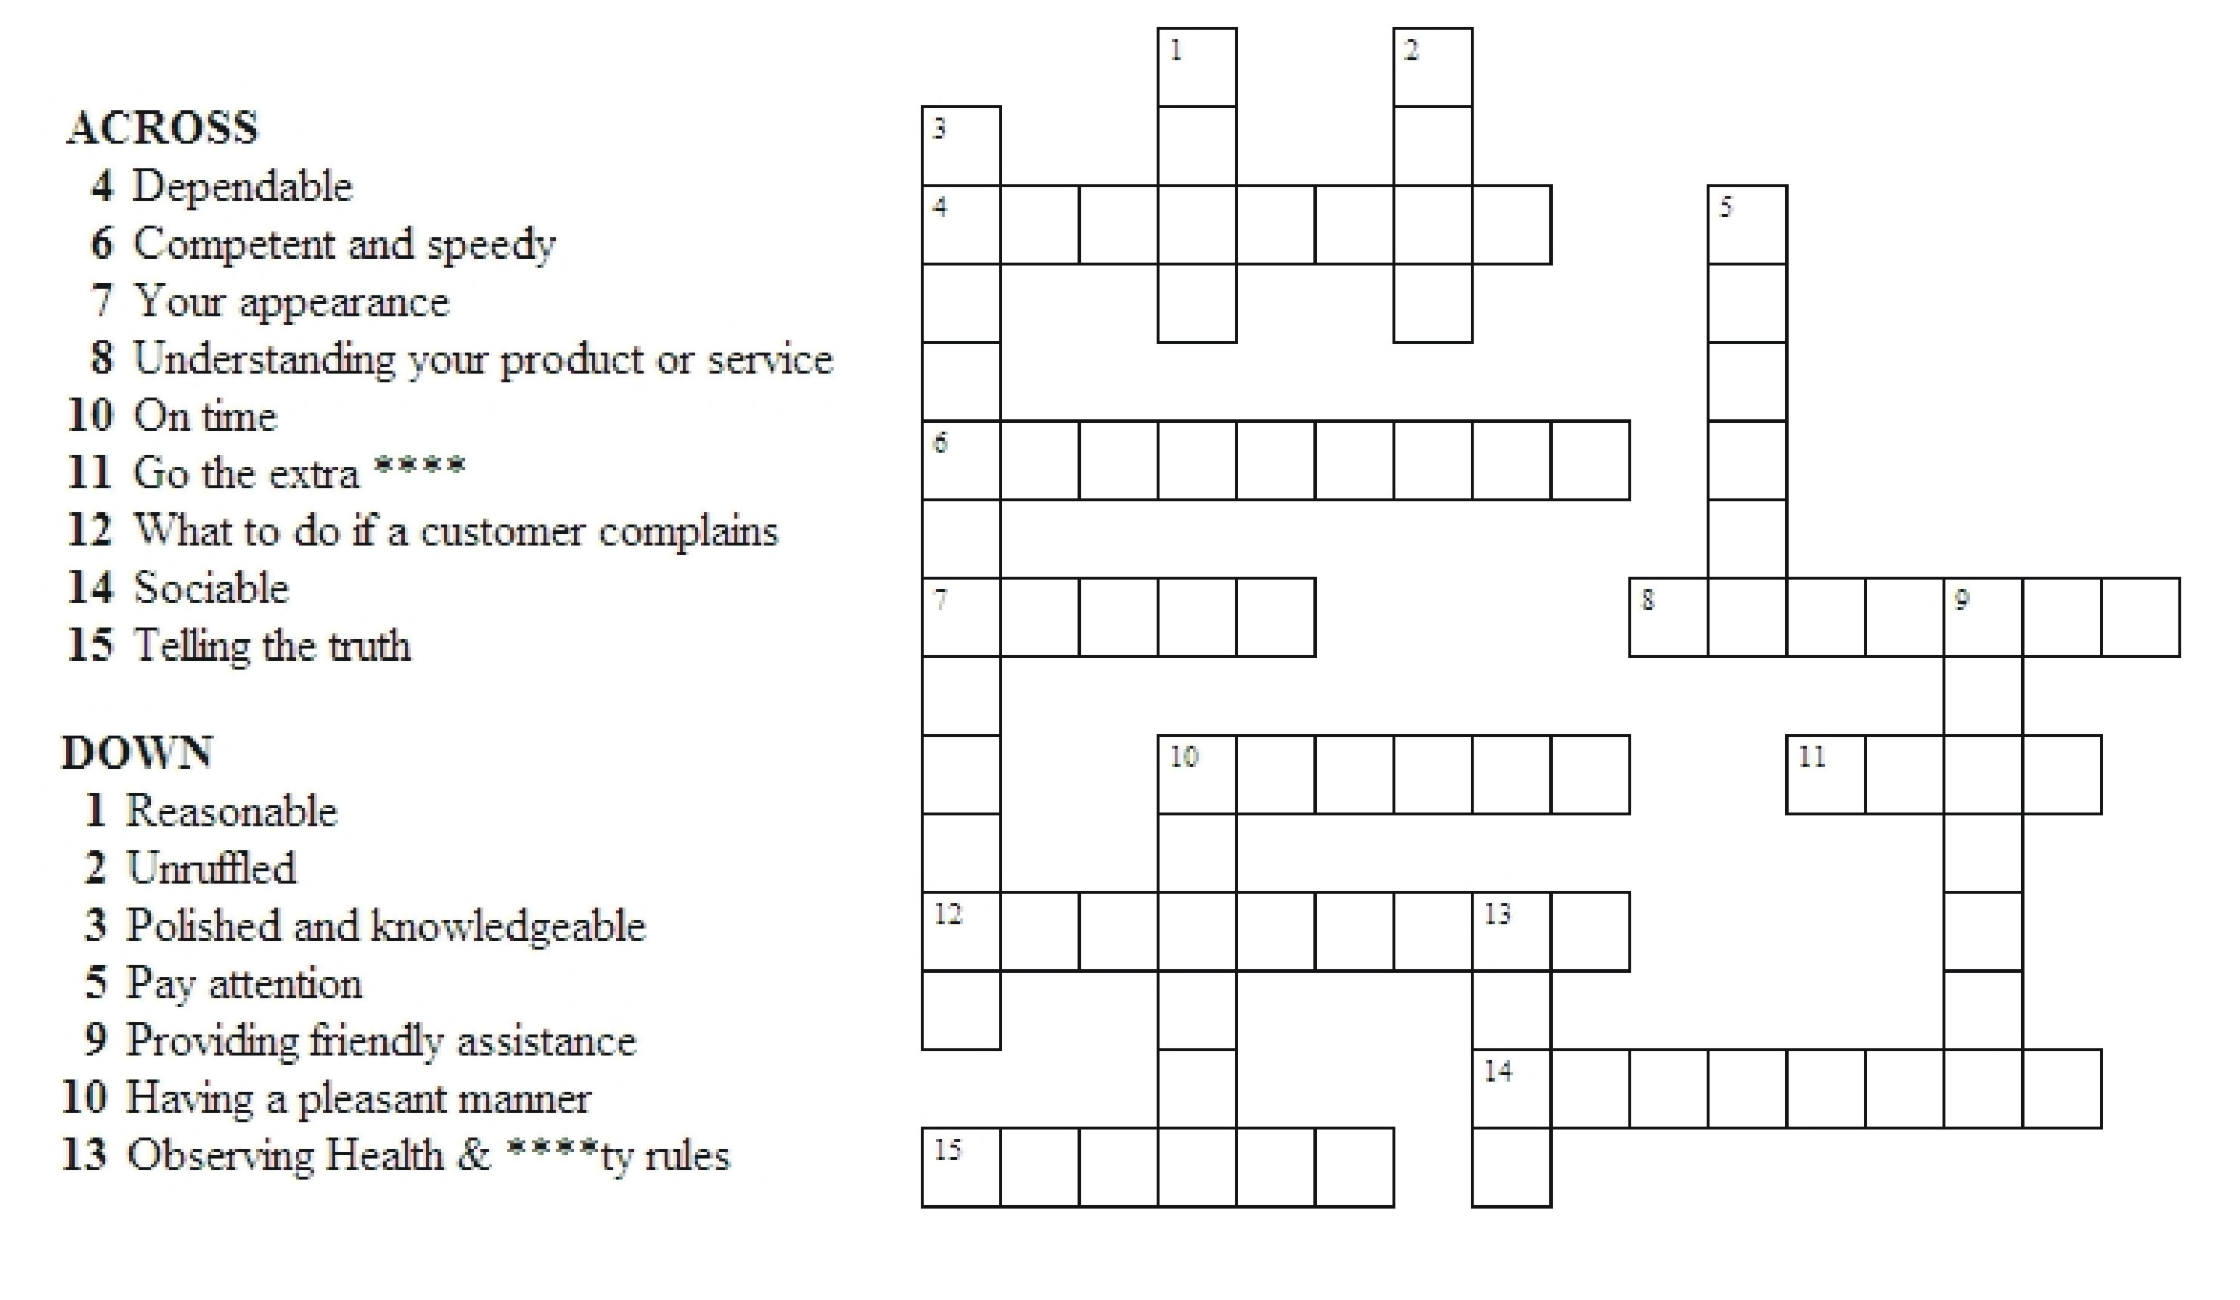

13. Give at least two examples of how your company’s procedures contribute to a consistent and reliable delivery of customer service. 1.p1.f ; 1.ku.n

14. Provide a few examples of the kinds of information your organisation keeps about its customers ? 1.ku.o

15. How do you keep your knowledge of products and services up to date. 1.p2.f

16. Describe how you would know if an additional product of service was available. 1.p1.g

The knowledge and understanding from unit 1 has been satisfactorily completed, all work carried out by the learner

Assessor’s Name: Signature:

The work in this unit is all my own

Learner’s Name: Signature: Signature:

Date:

Assessor Feedback:

Below are the standards for Unit 1.
Working with your assessor you will need to provide evidence that you are competent in each standard

UNIT 1 Customer Service Standards

When you prepare to deliver good customer service you must consistently:

1.p1a) explain what your organisation does and the types of customers it has
1.p1b) describe who’s who and who does what to provide customer service
1.p1c) describe who to go to for information or help when dealing with customer service issues
1.p1d) give examples of the kinds of information your colleagues may need from you so that they can give good service to customers
1.p1e) give examples of the ways an organisation could build a good reputation and the ways a reputation could be damaged
1.p1f) explain why company procedures are important to good customer service

1.p2a) list your organisation’s services or products
1.p2b) answer simple customer questions about your organisation’s products or services
1.p2c) explain why good customer service is important for your organisation
1.p2d) explain the effects of providing poor customer service
1.p2e) explain how your job is important in providing good customer service
1.2f) explain how you keep information about products or services updated
1.2g) describe how you would know when a new or additional service or product is available

To be competent at preparing to deliver customer service you need to know and understand:

1.ku.a) what the organisation does
1.ku.b) what services or products the organisation provides
1.ku.c) what the key features of the organisation’s services or products are
1.ku.d) what the key benefits of the organisation’s services or products are
1.ku.e) what the structure of the organisation is
1.ku.f) what a customer is
1.ku.g) who the organisation’s customers are
1.ku.h) what building an organisation’s reputation means
1.ku.i) what can damage an organisation’s reputation
1.ku.j) what customer service is
1.ku.k) how customer satisfaction depends on customer expectations and service delivery
1.ku.l) how customer service affects the success of the organisation
1.ku.m) the key customer service requirements of the job
1.ku.n) how company procedures contribute to consistent and reliable customer service
1.ku.o) the kinds of information the organisation keeps about its customers

On-programme administration checklist
Activity to be completed at the end of this unit | Assessor’s initials
1) Complete Action/Review Plan with learner
2) Forward copy of assessment plan/review to Administration
3) Update Skillwise

All administration for the end of Unit 1 is complete

Signed…………………………………………. Date………………

