UNIT 252

Understanding the retail selling process

What is this unit about?

What am I going to learn?

The selling model and closing sales. Identifying customers’ needs and using product knowledge to promote sales.

The five steps of the selling model. How questions can identify customers’ needs and the benefits of product knowledge.

What is selling?

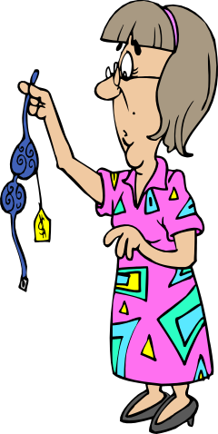
Selling is a skill used in many industries, including retail. In a retail environment, customers will often enter the shop having already decided what they want to buy and how much they want to spend. In these circumstances, your part in the process is to recognise when customers are demonstrating buying signals.

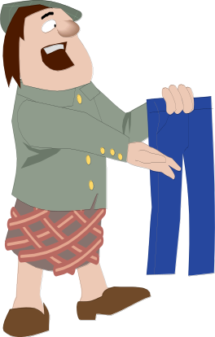

BUYING SIGNALS | NON-BUYING SIGNALS
Examining price tickets | Talking to other customers
Looking around for fitting room | Sitting outside fitting rooms
Looking at their watch | Flicking through stock
Approaching till with payment | Entering or leaving store
Reading the care label closely | Walking through department
Making eye contact | Standing looking out of the door
Making hand gestures | Tending to children
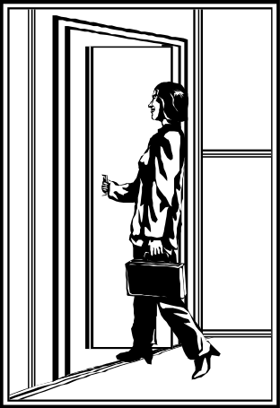

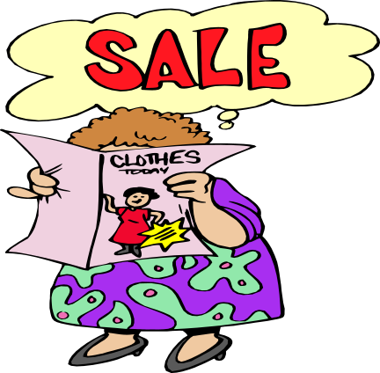

What are the five steps of the selling model?

1. Identify the customer’s needs
2. Present solutions that satisfy the need
3. Check the customer’s commitment
4. Overcome any objections
5. Close the sale

Before starting the five steps it is essential to establish a rapport with the customer. Remember people buy from people they like or identify with.

To identify the customer’s needs it is necessary to ask them questions. We explained the difference between open and closed questions in Unit 251. In identifying the customer’s needs you will use both types of question and also probing questions. These are used to follow up open questions in order to gather more detailed information. For instance: You ask a customer what they are looking for and they reply ‘a raincoat’. You now ask ‘what colour?’, ‘what size?’, ‘what price range?’. These are examples of probing questions.


Once you have a good idea of what the customer wants, you can show them the stock you have that meets their needs. Point out the features and benefits of the various alternatives, giving the customer as wide a choice as possible.

At this stage, ask the customer a question which checks whether you have satisfied their needs. For instance: ‘which of these raincoats do you prefer?’ The answer to this question will enable you to identify whether the customer is ready to buy or whether there are objections you need to overcome.


If the customer does not appear to be ready to buy, you need to find out what their objections are. It may be the price, it may be that none of the alternatives you have offered them exactly matches their needs or it may be a practical issue such as they don’t have transport to take the item home in, or they don’t have their credit card with them. Once you have identified their objections, try to find a way of overcoming them. If price is the problem, you may be able to offer a discount, offer a less expensive alternative or emphasise the value for money of the product. If the customer says nothing exactly matches their needs, this may be an excuse to disguise the fact that the real problem is the price, or you may need to revisit stage 1. If the problem is a practical one, overcome the problem. For instance: Offer free delivery, offer to keep the item aside for later collection, offer to take a deposit and keep the item aside.

If you have successfully overcome any objections you will have reached the point where you can close the sale. This is when the customer hands over their credit/debit card or their cash and you are in a position to ring up the sale. You need to know what payment methods your shop takes. Just about everybody takes cash, but do you take cheques, credit cards, debit cards?



Whatever method of payment is offered care must be taken; cash may be counterfeit - check for watermarks, foil strips etc. Your shop may use detector pens or UV light detectors when checking cash; cheques may be forged or stolen – check that signatures match, words and figures agree etc; credit or debit cards may be stolen or cloned – make sure you know and understand the authorisation procedures.

These are some examples of payments accepted in most shops and what to look for. Your business may have floor limits which you will have to know about. Company procedures should be followed at all times.

Remember: If in doubt check!

What are the benefits of keeping product knowledge up to date?

Whatever sort of shop you work in, the products you sell will regularly change. You may have seasonal stock such as overcoats or swimwear, cold remedies or sun tan lotions, fresh salad or winter vegetables. On the other hand you may have new technology such as blu-ray recorders replacing video recorders, or e-books replacing paperbacks. Because of this you must make sure that you regularly update your product knowledge in order to maximise sales.

It is important that you know more about the products and services you are selling than your customers do when they come into the store.

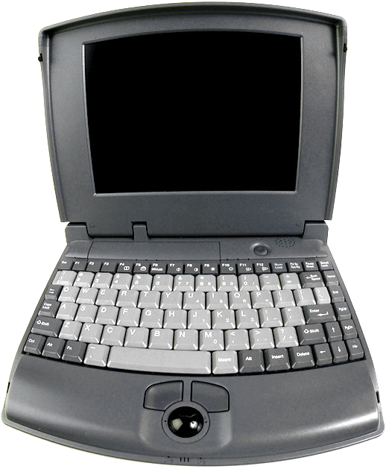

Information can be found in all sorts of places:

- manufacturers’ literature
- trade literature
- product packaging and labelling
- product instructions
- point of sale material
- colleagues and supervisors
- suppliers’ training
- company briefings
- internet or intranet

DON’T BE AFRAID TO ASK!!!!

The most important things to know about products, especially if you are demonstrating them to customers, are their features and benefits. What are the differences between features and benefits? Features describe what a product is or has, benefits describe what it does for you. Below are some examples, obviously there are other features and benefits to each item!!

FEATURES BENEFITS
 Remote control Ease of use

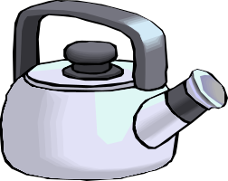 Chrome Co-ordinates

 Wool Hard-wearing

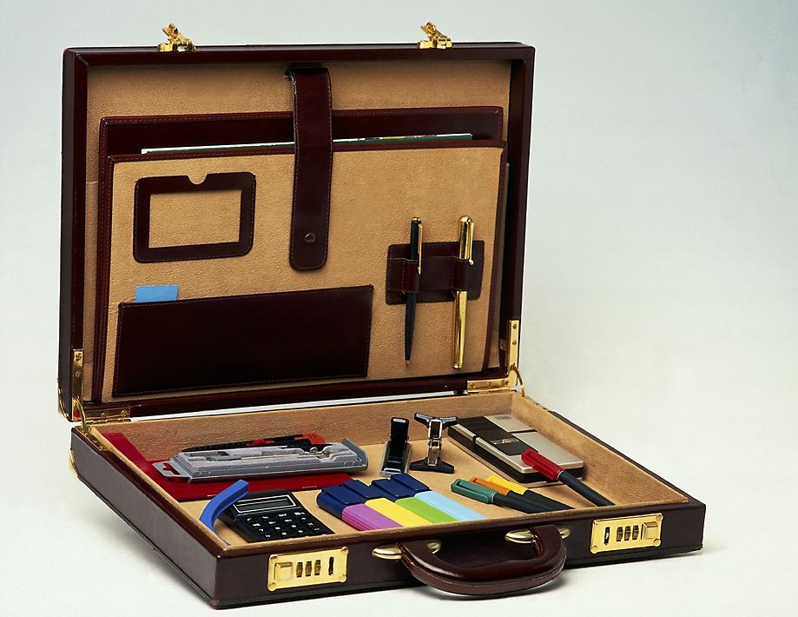 Combination Security

 Stalk removed Less waste

Remember, customers may explain their needs in terms of features, but they make buying decisions based on benefits. For instance: they may want a wool carpet, but they buy it because it is hard-wearing.

What can I practise?


Activity 1

Describe how a florist might go through the five steps of the selling model when serving a potential customer looking for flowers for a wedding.

Activity 2

Suggest probing questions which might be asked by the sales person in each of the following situations.

A mother buying shoes for a child


A pensioner looking for value for money ingredients for a meal

A father looking for a suitable present for his son in an electrical store




A customer in a pharmacy looking for a cold remedy



A young couple looking for an engagement ring

Activity 3

Which of the following are features and which are benefits?

Self-setting Convenience

Immediate use Open 24 hours

Batteries included Ease of use

Instant communication 50 number speed dial
Features Benefits



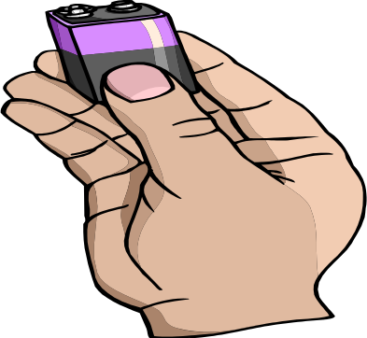




Sample questions

The test will consist of 20 multiple-choice questions. Try the following examples of questions on this unit.

Using effective questioning within the sale process enables the salesperson to

a identify customer needs
b make the customer feel welcome
c find out if the customer is ready to be served
d reduce the time spent with the customer.

Which one of the following is an example of an open question?

a Can I show you something in our new range?
b Would you like to see this in another colour?
c Is this the model you are looking for?
d What style did you have in mind?

Which one of the following describes a benefit of a digital camera?

a Number of pixels.
b 10 x zoom facility.
c Pictures instantly available.
d Available in a number of colours.

Which one of the following describes a buying signal?

a Asking a salesperson for directions to the restaurant.
b Asking a salesperson if the store is open on Sundays.
c A customer saying goodbye to a relative.
d A customer looking around for a salesperson.

You have come to the end of Unit 252 -Understanding the retail selling process.

You should now be able to:

- Outline the five steps of the selling model
- Explain why an effective rapport needs to be created with customers
- Explain the importance of effective questioning to the sales process
- Explain how linking benefits to product features helps to promote sales
- Explain why products must be matched to customers’ needs
- Explain the importance of closing the sale
- Define ‘open’ and ‘closed’ questions and state the purpose of each in the selling process
- Define what is meant by ‘probing’ questions and state the purpose of these in the selling process
- Identify questions which can be used to establish sales opportunities
- Explain how comprehensive and up-to-date product knowledge can be used to promote sales
- Describe how the features and benefits of products can be identified and matched to customers’ needs
- Describe a range of methods for keeping product knowledge up-to-date
- State what is meant by a ‘buying signal’ and describe the main buying signals the salesperson needs to look for
- Describe the main ways of closing sales

